Project Proposal

GeoFood

Use QR Codes from source to supermarket to track:

who grew the food, where it was grown

and how it got into your hands

**Group N:**

Omid Ayobee oayoo001@gold.ac.uk

Marcell Batta mbatt001@gold.ac.uk

Roland Dan rdan001@gold.ac.uk

Saifur Rahman srahm039@gold.ac.uk

Kevin Roditi krodi001@gold.ac.uk

Abul Siddique asidd002@gold.ac.uk

Wojciech Tyziniec wtyzi001@gold.ac.uk

Goldsmiths, University of London

IS52018C: Software Projects 2017 / 2018

1. User Need Overview & Concept Introduction 3

1.1 Purpose 3

1.2 Concept Introduction 3

2. Data gathering and requirements 3

2.1 Stakeholders 3

2.2 Market research 4

2.3 Personas 4

2.4 Potential user base 4

2.5 Project requirements 4

3. Functional specification 5

3.1 Functional Requirements Tables 5

3.2 Use Case Diagrams 5

3.3 Class Diagram 6

3.4 Sequence Diagram 6

3.5 State Diagrams 6

3.5 Collaboration Diagrams 6

4. Ethical Audit 6

5. Prototypes 7

5.1 Website 7

5.2 Mobile Application 7

6. Technical architecture 7

7. Evaluation Plan 8

7.1 Basic functionality testing 8

7.2 Code review 8

7.3 Static code analysis 8

7.4 Unit testing 8

7.5 Single-user performance testing 8

8. Project management 9

8.1 Project overview and deliverables 9

8.2 Process model and organisational structure 9

9. Conclusion 9

10. Bibliography 10

A. Appendix 11

A1. Definitions, acronyms and abbreviations 11

A2. Tables, drawings and diagrams 12

# 1. User Need Overview & Concept Introduction

## 1.1 Purpose

The purpose of this report is to provide a comprehensive description of the idea, functionalities and implementation plan of the GeoFood web platform.

The aim of this project is to implement a dynamic web application for businesses and a mobile application (for Android and iOS) for clients. These two applications will communicate with each other through a web service which will also be responsible for fetching data from a database.

## 1.2 Concept Introduction

Our journey into the world of software design and project management started with one simple question - how can we make life better? It is a big question and a bold statement we know, but one activity that is directly proportional for better living is nutrition. The healthier you are the happier you are, it is simple as that!

Nowadays, we’re bombarded with thousands of products. You have an incredible amount to choose from. For example bananas, when you walk into a store there is a large variety of bananas to choose from. They are from different countries, they have been grown using different various methods, the carbon footprint is different, how can we tell if it is a fair trade or not? The consumer has no information about these products and cannot make a moral healthy decision. Another example is all these products that are advertised that are organic, fair trade, high quality, eco friendly. But how exactly do we know that what they are advertising is true, who can confirm it? The answer is no one.

We are developing a mobile application that will keep track of all these questions that the consumer might have and that will verify if a product is as organic and healthy as advertised. The consumer will have access to all this information just by using an app on their phone and scanning the products QR Code. The product’s QR code will contain all the information of how, who, where has it been grown, carbon footprint, how long did it take to get in front of customer, what routes, stops did it take and we have designed a special algorithm to calculate an overall satisfaction of the said product taking all the variables mentioned.

# 2. Data gathering and requirements

## 2.1 Stakeholders

Stakeholders are any groups or individuals who can affect or are affected by an organisation, strategy or project. A Stakeholder can be internal or external. There are many stakeholders to our project but however the main stakeholders of our project are the farmers, supermarkets and customers.

Our application will be designed to manage the front end and the back end. The front end of our application will deal with information from the farms slaughterhouses. Their input will be data such as where the products has been produced and where they are sent from.

The middle input are warehouses and places where the different type of products has been dispatched.

The end input will be supermarkets and restaurants where they will be selling that product.

Gathering this data will help us to present it to the customers, where they will be able to scan the QR code and it will provide them with all the information regarding the product.

## 2.2 Market research

The purpose of market research is to examine the market associated with a particular good or service to determine how the audience will receive it. In order to gather all the information, we need for our project, we had to do some primary and secondary research such as interviewing our user base and doing a lot of online research.

The main goal of our research was to find out how our idea will fit in the industry; how can we improve our idea to stand above the competition and how well our idea will be received by customers. According to our research most customers thought our idea was really useful and some customers went on to say that it could change many people’s lives as most customers don’t believe their product comes from where the supermarkets have advertised, one customer went on to say, "I am a truly cynical consumer; just because supermarkets put photos of their farmers on meat packages, doesn't reassure me"

## 2.3 Personas

A marketing persona is a composite sketch of a key segment of your audience. personas are important to our project because it gives the internal stakeholders an idea of what their potential audience will be. As you can see in **Figure 15**, we have a good description of what our potential users can be, it includes a full profile of their work, goals, motivations, targets, likes and dislikes. This helps us make our application more appealing towards them and meet their needs.

## 2.4 Potential user base

Our projects user base is straight forward, our application is targeting the producers of the products, and the users of the product. Farmers, transporters and supermarkets will be our first group of users as they will be the ones using the application for scanning their goods' QR codes to tag the route they have taken to arrive at their destination.  
  
As for the other group the users of the main application who will be scanning their items’ QR codes to check where their food has really come from and how it got to them. This means our application will have a broad audience, however majority of the people will mostly be young adults. To make the application more appealing towards older people, we will make the user interface as simple as possible.

## 2.5 Project requirements

Requirements management is the process of capturing, assessing and justifying stakeholders’ wants and needs.

**Functional requirements:**

- The Application should allow users to be able to scan QR codes on their products into their phones.

- The application should allow supermarkets and customers to track their food and provide them with the history of the product.

- Each user should have their individual accounts

- Users will be able to track the history of their products.

**Non-functional requirements:**

- The application should Run on all platform.

- Have a clean object-oriented design allowing good maintainability

- The application should be user friendly and aesthetically pleasing, appropriately designed.

- Application instructions should easy to understand, abstract but clear.

# 3. Functional specification

The essential functional element of our app will be of course a phone. To be more exact any smartphone with a camera capable of scanning QR codes. You will be required to have a valid internet connection when trying to scan an item to access the database for all the information. When trying to add a new item to a company’s product list or contribute to the transportation paths for a certain item, the phone will need to have your geolocation which will also require an internet connection to store the data.

## 3.1 Functional Requirements Tables

***Table* 1** refers to the functional requirements for the app on the company owner side. It shows all the functions that we would either want or need in our project. Majority of these features will be a necessity but there are some such as ‘FR112’ which would be optional. This means if during the app development phase, we start running out of time this would be one of the first things to get removed to realistically finish the project on time.

***Table 2*** is the same functional table except it is for functions that the customers will use. Here we have more things that we could potentially remove as these functions are more for the sake of clarity.

***Table 3*** shows the functional requirements for the website that we will create. Most of the functionality of the website will only be used by admins of the website and the company owners to sort out their company related issues.

## 3.2 Use Case Diagrams

The use case diagrams show us how the users will interact with the system and the different cases that can happen. **Figure 1** and **figure 2** shows the use case for the mobile app that we have split up into consumer and company owner respectively.

As for **figure 3**, that is the use case diagram for the website split into three separate sections. We don’t have many if not any plans for adding the customers to the website since it would just overcomplicate the system, however we have still added it just in case we want to change our minds along the way.

## 3.3 Class Diagram

**Figure 4** displays the full class diagram that we plan to implement into our program, showing all the links between the classes. It includes all the variables that a certain class will use along with the functions related. This will most likely be updated as we go along once we run into issues during the actual development phase, however it does provide us with a decent starting point. It also points out the relations between the classes which could be beneficial once building the databases.

## 3.4 Sequence Diagram

The sequence diagrams show how the different objects interact with each other. In **figure 5** and **figure 6** you can see the different interactions between them in certain scenarios. It also gives us a good idea of what functions are being used together and what calls might be made between them.

## 3.5 State Diagrams

The state diagrams show the different states that the system can be in depending on the transition occurring. In **figure 7** and **figure 8** it becomes clear how the system reacts to different inputs/button presses and what kind of functions get called when certain interactions are made.

## 3.5 Collaboration Diagrams

Collaboration diagrams are a combination of information from class, sequence and use case diagrams. They describe the relationship or collaboration between classes/objects and the related functions with them. In ***figure 9***and ***figure 10***you can see the collaboration between objects when a customer (***figure 9****)* or company owner (***figure 10****)* interacts with the system.

# 4. Ethical Audit

The key issues of concern in constructing a web application platform is the necessary privacy issues, which is required to be running in the background at all times to ensure a safe and secure process. The application itself will handle large quantities of data ranging from consumer details, which includes personal identifiable information such as name, addresses and contact information, as well as administration rights and access levels. In order to uphold and maintain the security of this data, we as a group must ensure we respect and contribute to the ethical objectives. This consists of performing work with due diligence and responsibility.

Furthermore, confirming that any work will not be associated with minors and vulnerable adults to meet the basic rights, this would lead on to encrypting any information which is handled or stored that is sensitive. To achieve this, we will safeguard usernames and passwords to reduce the likelihood of breaches and unauthorised access. In addition, we will retain information no longer than It is needed, and dispose of it in a safe manner. Additionally, users will be able to choose whether they would like their details to be shared amongst 3rd party companies. Based on this decision we must and will always abide by the user’s selected choice.

# 5. Prototypes

We held a group meeting dedicated for prototype/design to make sure we all agree together on how we plan to have the app and website look. We initially just drew rough sketches to get ideas going for functionality.

## 5.1 Website

The sketches (***figure 11****)* we made were just to let us decide on how and what the pages of the website should contain and how everything should be placed. At this point we haven’t put any emphasis on creating actual designs or deciding on colours and such.

After our meeting and once the sketches were finalised we had someone create a better looking digital version of these wireframes. In these (***figure 12****)* we have more text with placeholders for the images and logos.

## 5.2 Mobile Application

There was a lot of discussion on where everything should be in the app. So far, we have decided mostly on the designs in ***figure 13***which we then ended up transferring over to a digital version (*see* ***figure 14****)*. We looked at a few different apps to draw inspiration from, mainly snapchat since both the apps’ focus is using the camera. It was hard to agree on the same design with everyone along with making sure that the functionality is present, there are no unclear instructions and everything is intuitive for the most part.

# 6. Technical architecture

These are the technologies that will be used to implement and create our app and project as a whole.

For the application itself we are going to use the following technologies:

**Swift(IOS)/Android Studio(android)** – these are the main programming languages that we are going to use to create the app itself. They are both an easy yet effective approach to app development and are the best available languages for mobile app development

For the Website we will be using the following technologies:

**HTML5** – HTML5 will be the main base used to create the website and its content. As it is the latest evolution of HTML it allows to create a more dynamic website due to added technologies.

**CSS** – CSS will be used to style the webpage and HTML content by setting the colour scheme used in both the web page and mobile application, layering information on the webpage, etc.

**JavaScript** - JS is the scripting language that’s going to be used to make the website more dynamic, this will be implemented throughout the webpage for example when displaying information such as graphs to the users.

**MySQL** – This will be the management tool used within the website and application, MySQL will contain all the data of the app as well as be used to gather information /data. This information can be used in different ways where user specific data is going to be displayed to users.

# 

# 7. Evaluation Plan

Our aim is to find the right balance between writing code and testing. It is really important to give testing enough time and importance especially that this is a group project and each individual will write their own piece of code towards the end product. Leaving obvious bugs in the code is a waste of time and a waste of other people’s time.

What we agreed on is this mix: 40% designing and writing code, 5% spent on code review and static code analysis, 25% spent on unit testing and integration testing and 30% on basic functionality testing and single performance user testing.

## 7.1 Basic functionality testing

Making sure that every button on the screen works and also making sure that every field that can have text as an input will work and not crash the software.

The goal here is to not let other people touch our work if it's going to crash as soon as they enter their own name in the username field. We will have an API feature so it will be tested that the basic API functionality works well before submitting it for more intensive testing.

## 7.2 Code review

Before code review the basic functionality, testing will be done. Everyone in the group will have to look at the code, even if it's not the code they wrote. Another pair of eyes looking at the source code can uncover a lot of problems.

## 7.3 Static code analysis

We are going to use tools that will perform analysis on the source code without executing it. These static code analyses will look for weaknesses such as security vulnerabilities and potential concurrency issues.

## 7.4 Unit testing

Each of us will write unit tests to make sure that the unit (be it method, class, or component) is working as expected and tested across a range of valid and invalid inputs.

We can also work with mock objects and virtualized services.

## 7.5 Single-user performance testing

Single-user performance on the front-end and making sure the software is responsive when only they are using the system. If it's taking more than a few seconds to display the web page or pull the products from the database, then the client-side code is slowing things down and must be fixed.

# 8. Project management

## 8.1 Project overview and deliverables

The project deadline is March 23rd, 2018. We work in a group of seven, that means we’ve got ~300 hours (that is our budget) per person (2100 hours as a team) to spend on this project.

**Project deliverables:**

1. Project Proposal Report - 15th Dec 2017
2. GeoFood System Implementation - 7th Mar 2018
3. Software Tests - 1st Mar 2018
4. Project Presentation - 8th Mar 2018
5. Final Report - 23rd Mar 2018

The first stage of the project (finished on 15th Dec 2017) was to decide on the project idea, start doing research and write the Project Proposal Report. After ten weeks, we progress to the next stage in which we build and test the actual software and write the Final Project Report.

The Gantt Charts (**Figure 16**, **Figure 17 and Figure 18**) present more detailed picture of the different phases of the project.

## 8.2 Process model and organisational structure

The project will be developed using the SCRUM model. For the second stage of the project we have planned nine weekly sprints. At the beginning of each sprint, we will take a small set of the functional requirements, decide how to implement it and then code it and test its functionality.

Team leader is responsible for scheduling group meetings and arranging the tasks for each of the team members and should always keep the team focused on its goal.

At the end of a sprint, team leader will schedule a group meeting where developers will discuss what they have done, what problems they encountered and demonstrate new working functionalities.

# 9. Conclusion

In conclusion, this project plans to relieve some of the stress on the food industry and bring some clarity to its customers through the use of QR codes and providing information about a product’s ‘journey’. It won’t be an easy task to complete, however it is doable looking at all the planning and research we have conducted. The difficult part of this project will be getting the farmers familiar with our system and making sure it is straightforward enough to not cause any confusion or delay their work. With thorough testing this shouldn’t be an issue.

# 10. Bibliography

**Books:**

* Ricketts, Ian. Managing Your Software Project: a Student’s Guide. London, Springer, 1998.
* Larman, Craig. Applying UML and patterns: an introduction to object-oriented analysis and design. Presence Hall PTR, 1997.
* Pressman, Roger. Software Engineering: A Practitioner’s Approach 5. London, McGraw-Hill, 2001.

**Online articles:**

* Qr-code-generator.com. (2017). QR Code Basics. [online] Available at: http://www.qr-code-generator.com/qr-code-marketing/qr-codes-basics/ [Accessed 29 Oct. 2017]
* WhatIs.com. (2017). What is QR code (quick response code)? - Definition from WhatIs.com. [online] Available at: http://whatis.techtarget.com/definition/QR-code-quick-response-code [Accessed 13 Dec. 2017].
* Brandenburg, L. (2017). *What Goes Into a Functional Specification?*. [online] Bridging-the-gap.com. Available at: http://www.bridging-the-gap.com/functional-specification/ [Accessed 13 Dec. 2017].
* The Balance. (2017). *What Makes Up A Gantt Chart? Find Out Here*. [online] Available at: https://www.thebalance.com/gantt-chart-components-2779538 [Accessed 13 Dec. 2017].
* Agilemodeling.com. (2017). *UML 2 Class Diagrams: An Agile Introduction*. [online] Available at: http://www.agilemodeling.com/artifacts/classDiagram.htm [Accessed 13 Dec. 2017].
* Ibm.com. (2017). *The class diagram*. [online] Available at: https://www.ibm.com/developerworks/rational/library/content/RationalEdge/sep04/bell/index.html [Accessed 13 Dec. 2017].
* Tammyworcester.com. (2017). *QR Codes Basics*. [online] Available at: http://tammyworcester.com/qr-codes-basics/ [Accessed 13 Dec. 2017].

# A. Appendix

## A1. Definitions, acronyms and abbreviations

Table 1 - definitions

|  |  |
| --- | --- |
| **Term** | **Definition** |
| GeoFood | The name of our project. |
| Consumer User | Someone who interacts with the mobile phone application to get information about products. It is also sometimes called customer or front-end user. |
| Business Users | Companies/business users that use the mobile phone application to add information about products. It is sometimes called non-consumer or back-end customer. |
| Web-Portal | A website used but companies and businesses to gather information about their products. |
| QR code | [2D bar code](http://searchmobilecomputing.techtarget.com/definition/2D-barcode) that is used to provide easy access to information through a [smartphone](http://searchmobilecomputing.techtarget.com/definition/smartphone). [1] |
| GPS | Global Positioning System |
| Stakeholder | People who have interaction with the application who are not developers |
| API | Application Programming Interfaces determine the operations, inputs, outputs, and underlying types of a component of software. [2] |
| CSS | CSS is used for describing the formatting and aesthetics of an item described in mark up language. [2] |
| GUI | GUI is the way that the majority of users interact with computers. It uses image-based operations (windows, icons, menus) to facilitate an easier and pleasant experience for users.[2] |
| LSB | [Location-Based Services](http://youappi.com.phonescoop.com/glossary/term.php?gid=276) used for information about the physical location of the device. |
| UDID | Unique Device Identifier’s are 40-character text strings assigned to Apple devices that allow app vendors to track users behaviour.[2] |

## A2. Tables, drawings and diagrams

Table 1: Functional Requirements for GeoFood Non-Consumer Mobile App.

|  |  |  |  |
| --- | --- | --- | --- |
| **Requirement ID** | **Requirement Statement** | **Must/Want** | **Comments** |
| FR101 | Users shall be able to download the mobile app through an application store. The application shall be free to download. | Must |  |
| FR102 | The app shall notify users about new releases. Users shall download updates in the same way as they download the mobile application. | Must |  |
| FR103 | First-time user of the mobile application shall see the log-in page when he/she opens the application. | Must |  |
| FR104 | To be logged in the user shall provide username, password and click login. | Must | Database storing all accounts registered. |
| FR105 | The app shall send a request to the GeoFood webservice and authenticate users. | Must | Webservice communicates with our database and sends a response. |
| FR106 | The app shall display a response from the webservice with authentication status. | Must | Simple “success” or “wrong username/password” animation. |
| FR107 | The app shall store the log-in information on the phone and in the future the user should be logged in automatically. | Must |  |
| FR108 | The app shall let the user logout of their account. | Must |  |
| FR109 | The app shall display a menu with possible actions. | Must | “List of products”, “Add new product”, “Scan a QR Code”, “About us”, “Logout” |
| FR110 | Users shall be able to click buttons from the menu. | Must |  |
| FR111 | The app shall display detailed product descriptions consisting of name and location history. | Must |  |
| FR112 | The app shall organise the list of products by product name or ID. | Want |  |
| FR113 | The app shall have a functionality to delete products from the list. | Must |  |
| FR114 | The user shall be able to add new products and provide more information about them. | Must | Location, timestamp, device ID |
| FR115 | The app shall allow users to generate new QR Codes based on the given information. | Must |  |
| FR116 | The app shall allow the items in the catalogue to be searched. | Must |  |
| FR117 | The app shall allow users to scan QR codes on products. | Must |  |
| FR118 | The app shall allow users to update information about products. | Must |  |
| FR119 | Users shall be able to save QR Codes as a “png” or “pdf” file. | Must |  |

Table 2: Functional Requirements for Geofood Consumer Mobile App.

|  |  |  |  |
| --- | --- | --- | --- |
| **Requirement ID** | **Requirement Statement** | **Must/Want** | **Comments** |
| FR001 | The app shall have a login screen where the users can login or register an account. | Must | Database storing all accounts registered. |
| FR002 | The app shall have a ‘skip’ option to carry on as a guest if they rather not register/login. | Must |  |
| FR003 | The app shall allow users to scan QR codes on products. | Must | Database storing all QR codes with information. |
| FR004 | After scanning a product, the app shall display information about the item. | Must | Database storing all information to do with a certain QR code. |
| FR005 | The app shall have a history tab for users that have logged in to view their previous scans. | Want | Database storing history of scans. |
| FR006 | The app shall let the user logout of their account. | Must |  |
| FR007 | The app shall allow the user to search for a product’s information. | Want | The user will search a catalogue or our database. |
| FR008 | The app shall have an ‘about us’ section telling the users about our app. | Must |  |
| FR009 | The app shall display a map when the user asks for transport information. | Must | The transport history will be stored in databases by the farmer/drivers. |
| FR010 | The app shall display a history tab where the user can see all their recent scans. | Want |  |
| FR011 | The app shall allow any logged in users to favourite an item. | Want |  |
| FR012 | The app shall display all the users’ favourites when requested. | Want |  |

Table 3: Functional Requirements for Geofood Website.

|  |  |  |  |
| --- | --- | --- | --- |
| **Requirement ID** | **Requirement Statement** | **Must/Want** | **Comments** |
| FR201 | The website shall have a home page that lists the purpose of the organisation. | Must | A clean, professional page to display most of the information. |
| FR202 | The homepage shall have link to the relevant app stores to download the app on the users preferred device. | Must | Google Play, Apple Store |
| FR203 | The homepage shall also have a section dedicated to product statistics. | Want | Top scanned products, best rating, hype, feedback and so on. |
| FR204 | The website shall have a search function. | Want | Search for a specific product. |
| FR205 | The website shall have a Contact/Helpdesk page. | Must | Email, Phone, Live chat - Businesses will be able to enquire about signing up. Also help or support with the app or any inquiries about the products. |
| FR206(a) | The website will have a Login page for businesses. | Must | Businesses will be able to login and manage their profile and catalogue. |
| FR206(b) | The website will have a Login page for admins. | Must | Administrators will be able to create/delete and view every catalogue and to edit/add/delete and view the products history. |
| FR207 | The website shall have a Logout page. | Must | Users will be able to Logout of their accounts. |
| FR208 | The website shall be linked to a database. | Must | All catalogues, products, accounts and statistics will be pulled from said database. |
| FR209 | The website shall have an algorithm that will calculate how “good” a product is. | Want | It will take all the products’ attributes, travelled distance, pollution and so on that were inputted by the user and give it a rating out of 100%. |

Figure 1: Geofood Consumer Mobile App Use Case Diagram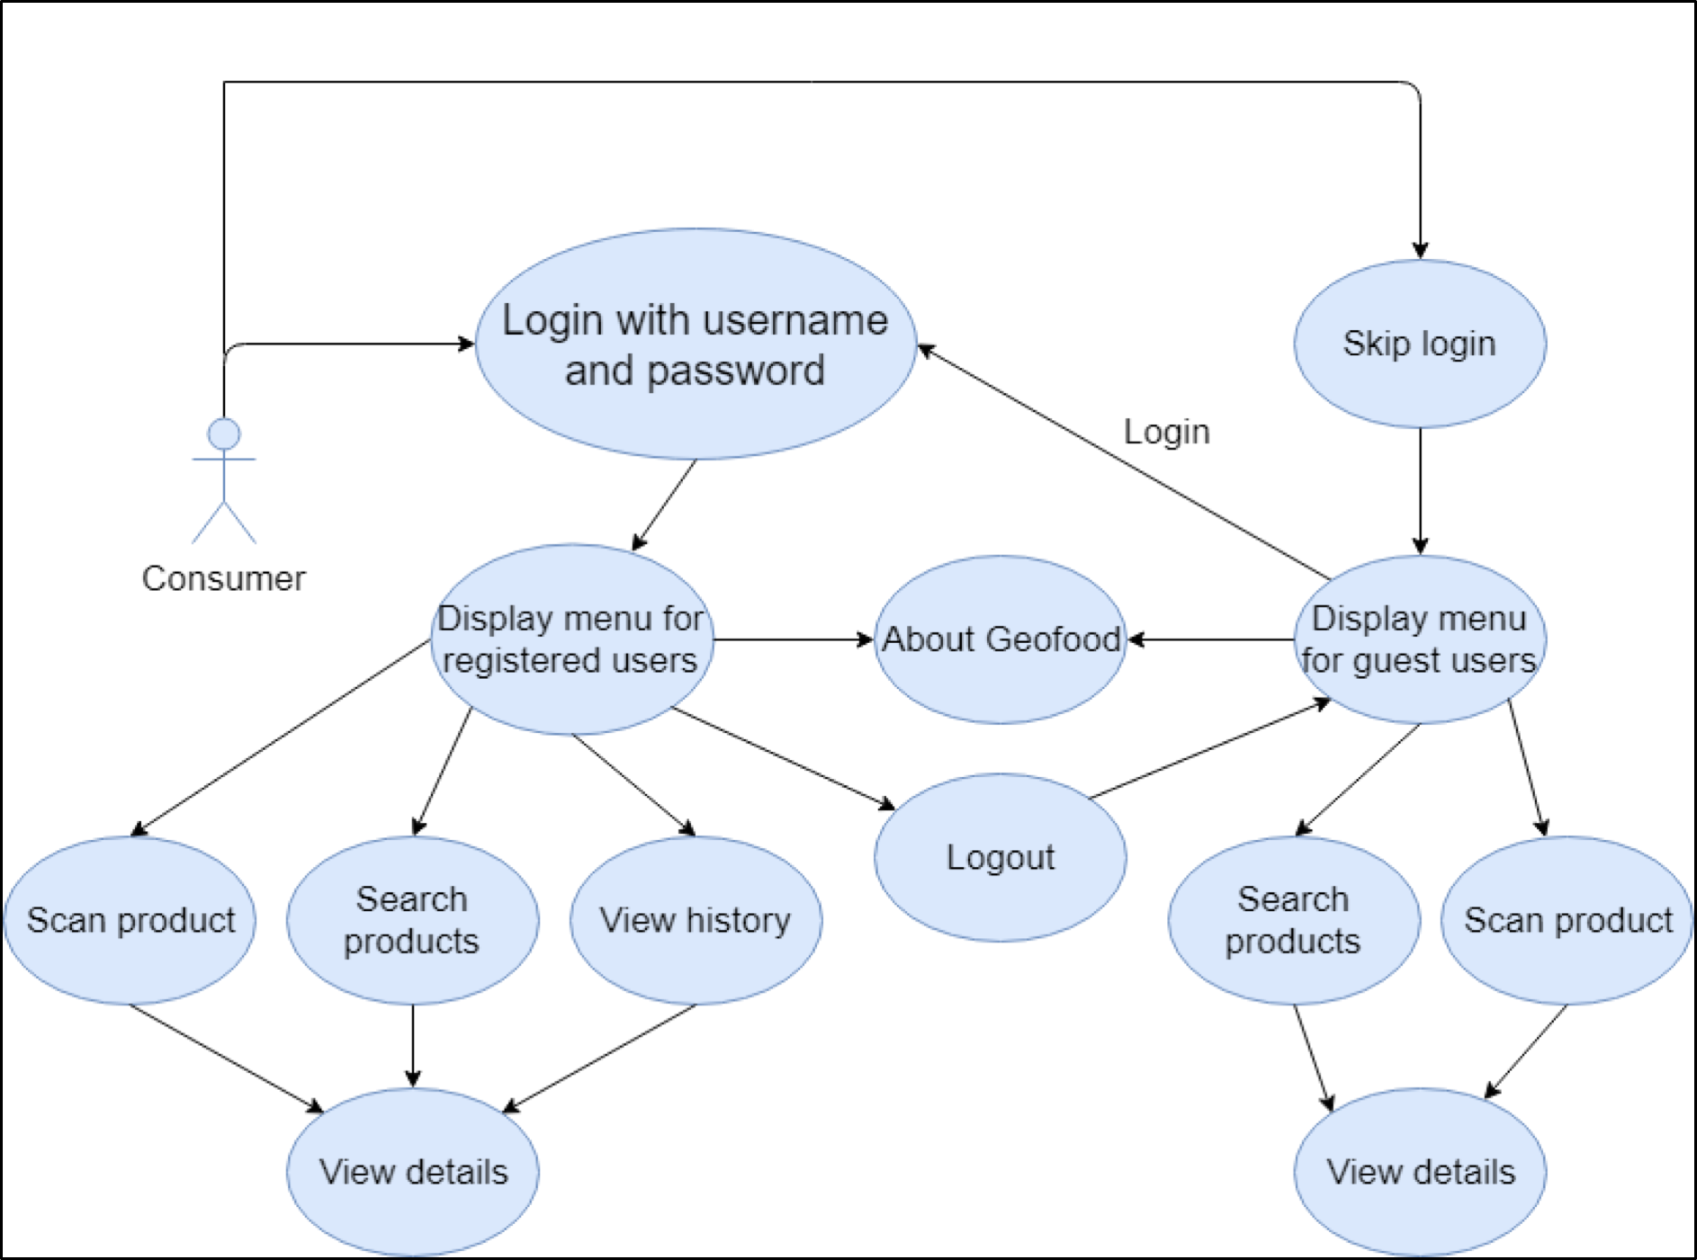

Figure 2: Geofood Non-Consumer Mobile App Use Case Diagram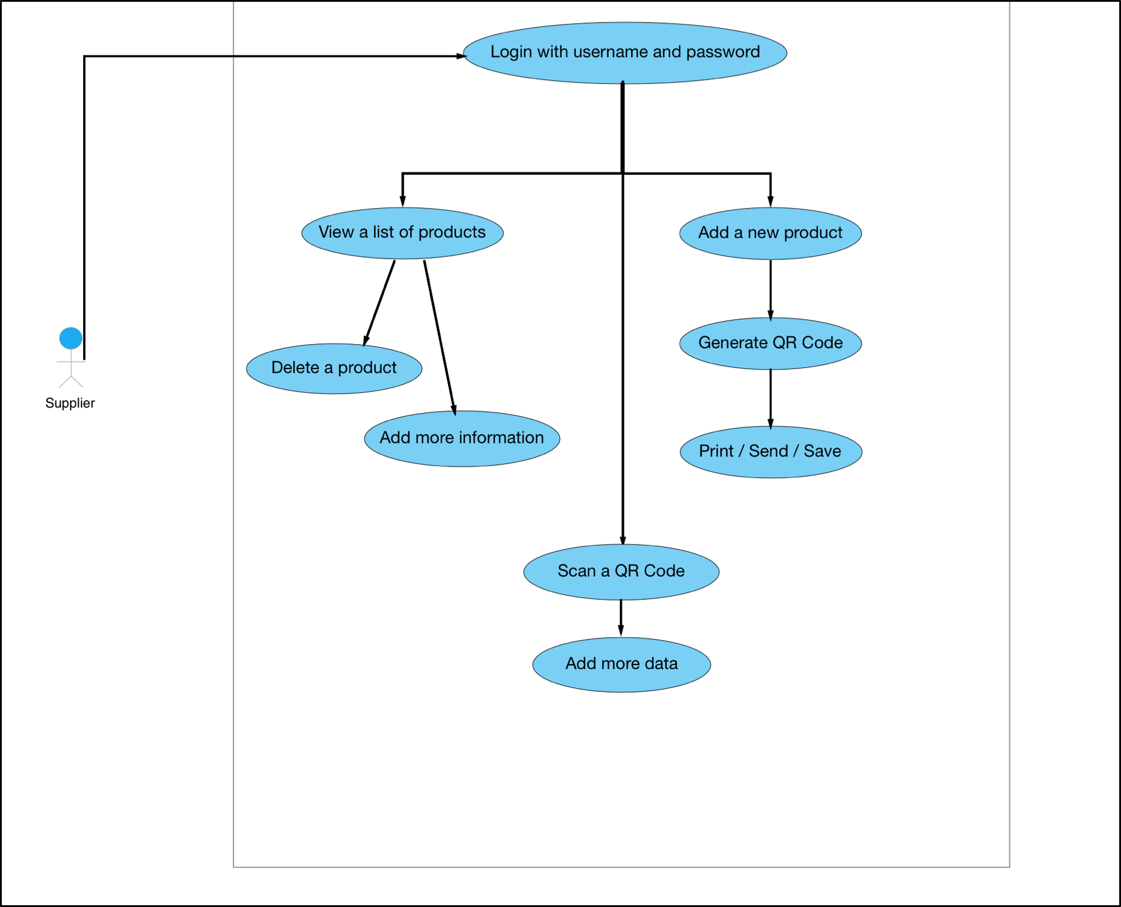

Figure 3: Geofood Website Use Case Diagram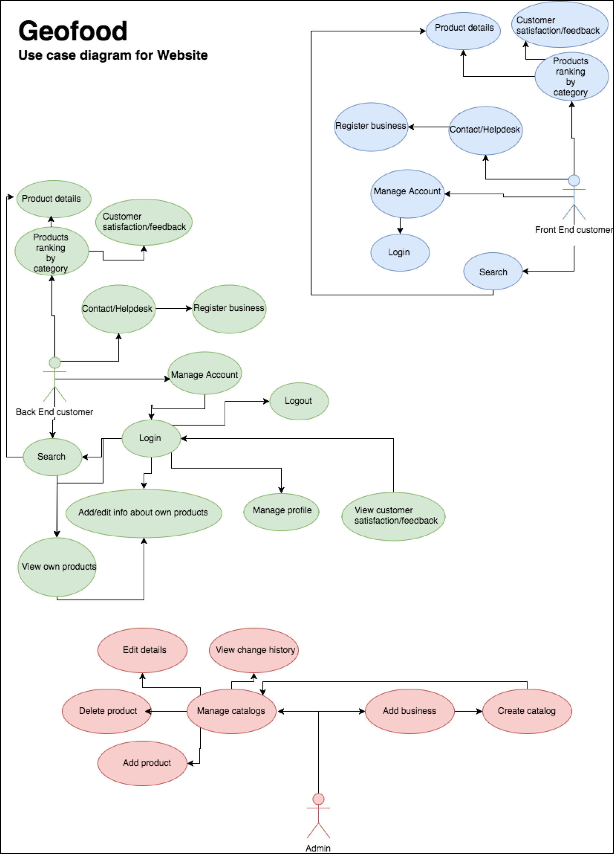

Figure 4: Full Class Diagram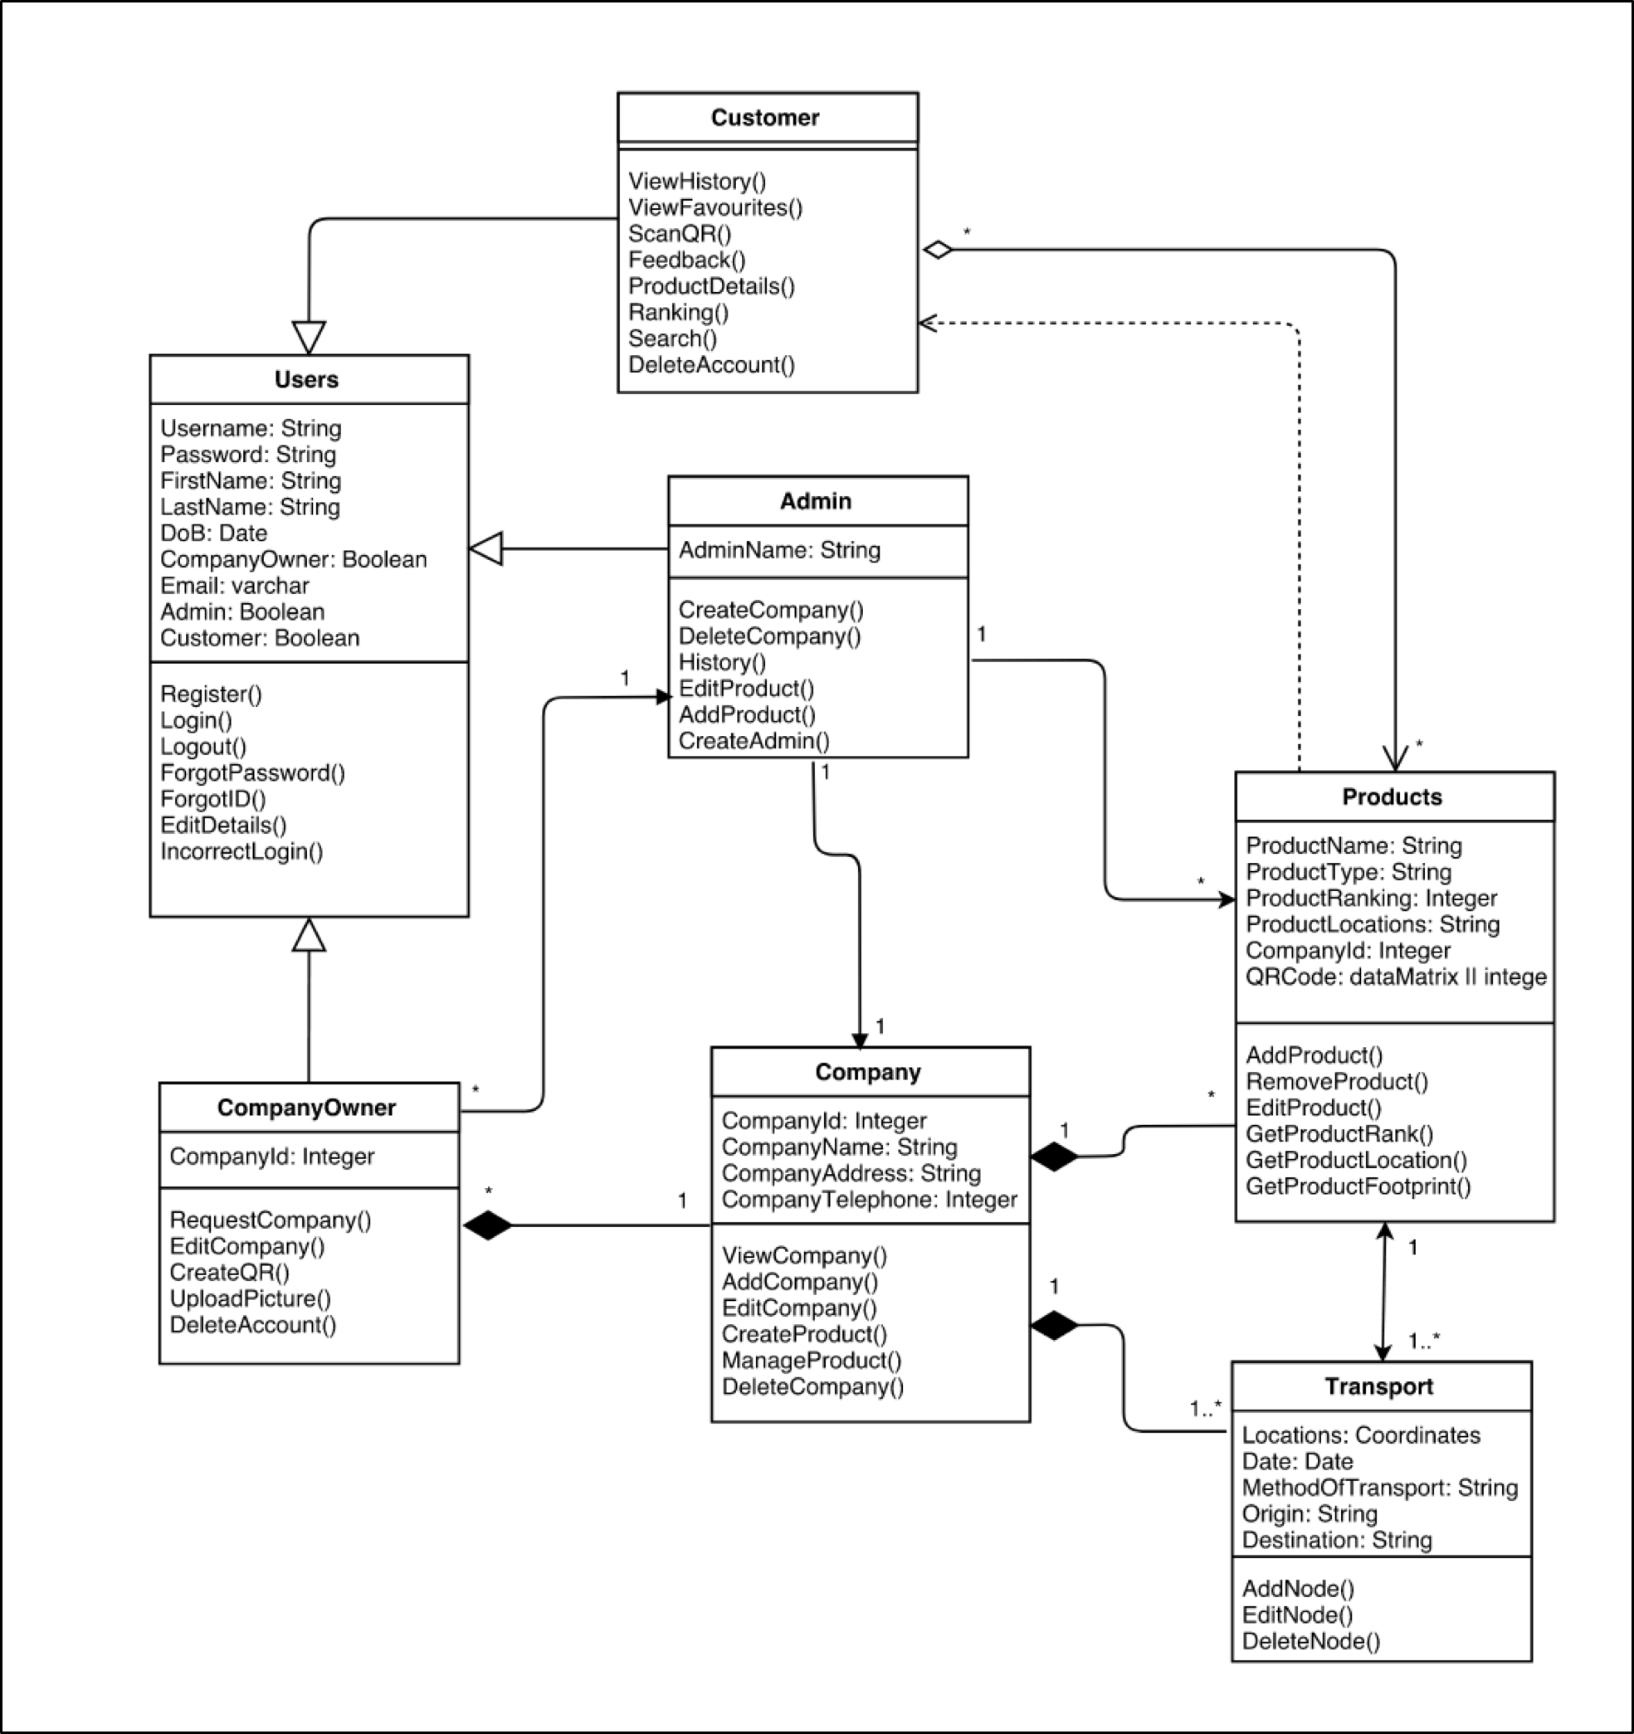

Figure 5: Sequence Diagram for Customers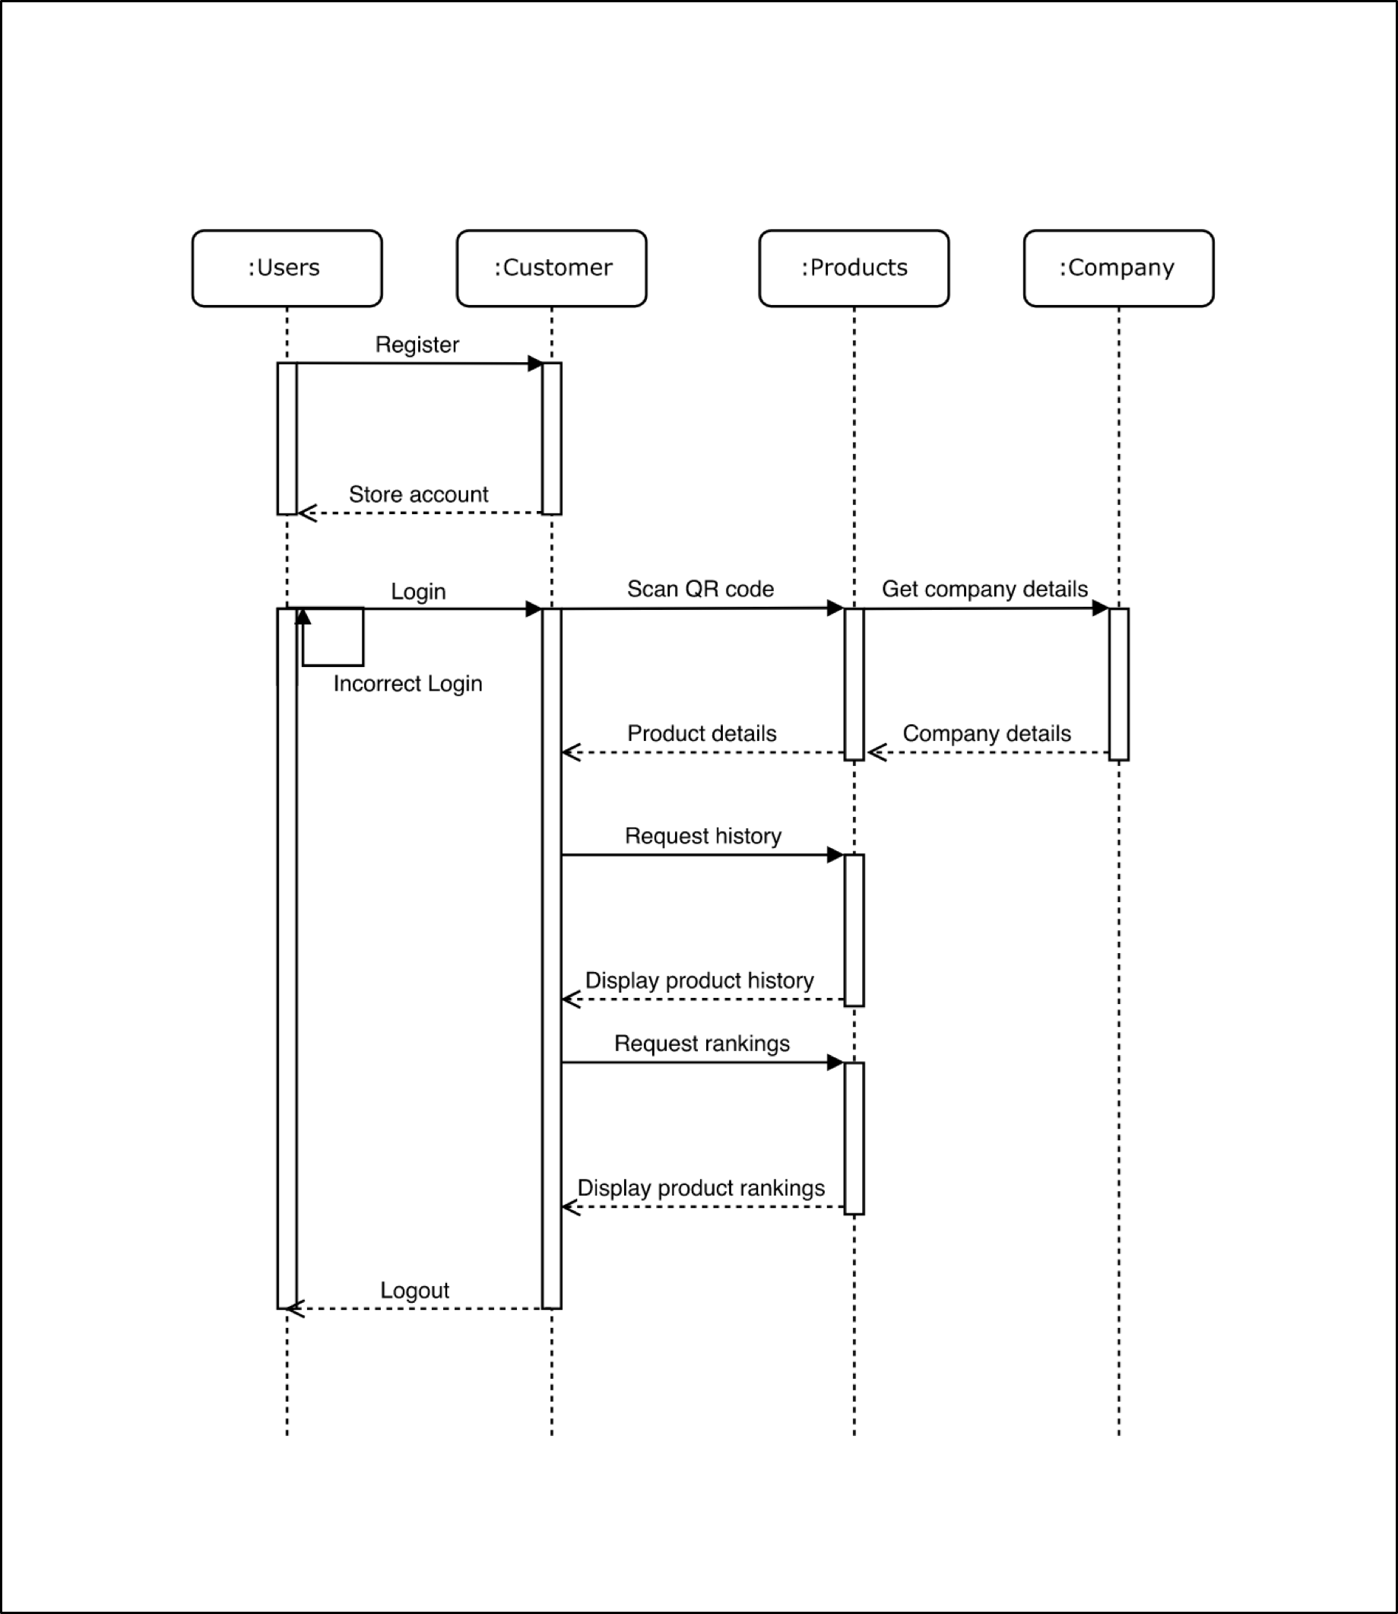

FIGURE 6: SEQUENCE DIAGRAM FOR COMPANY OWNERS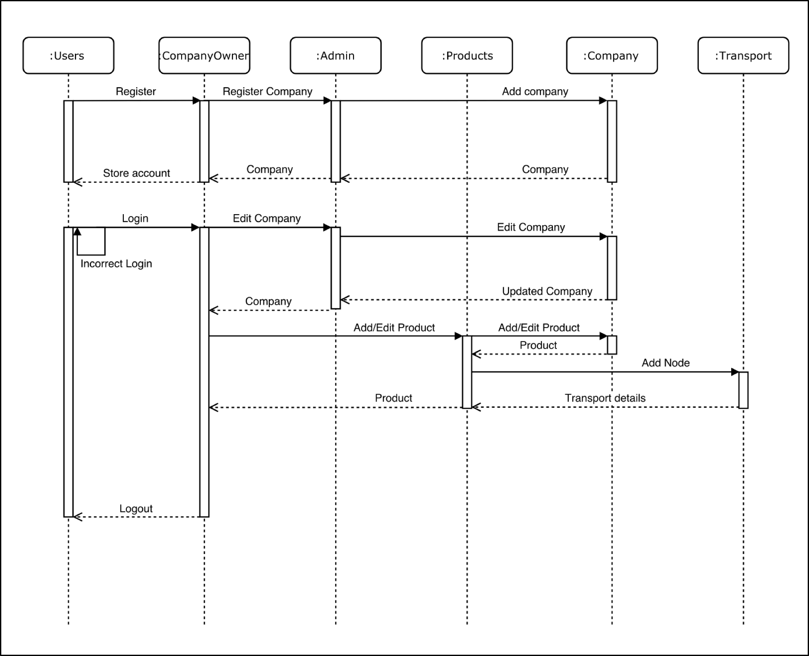

FIGURE 7: STATE DIAGRAM FOR CUSTOMERS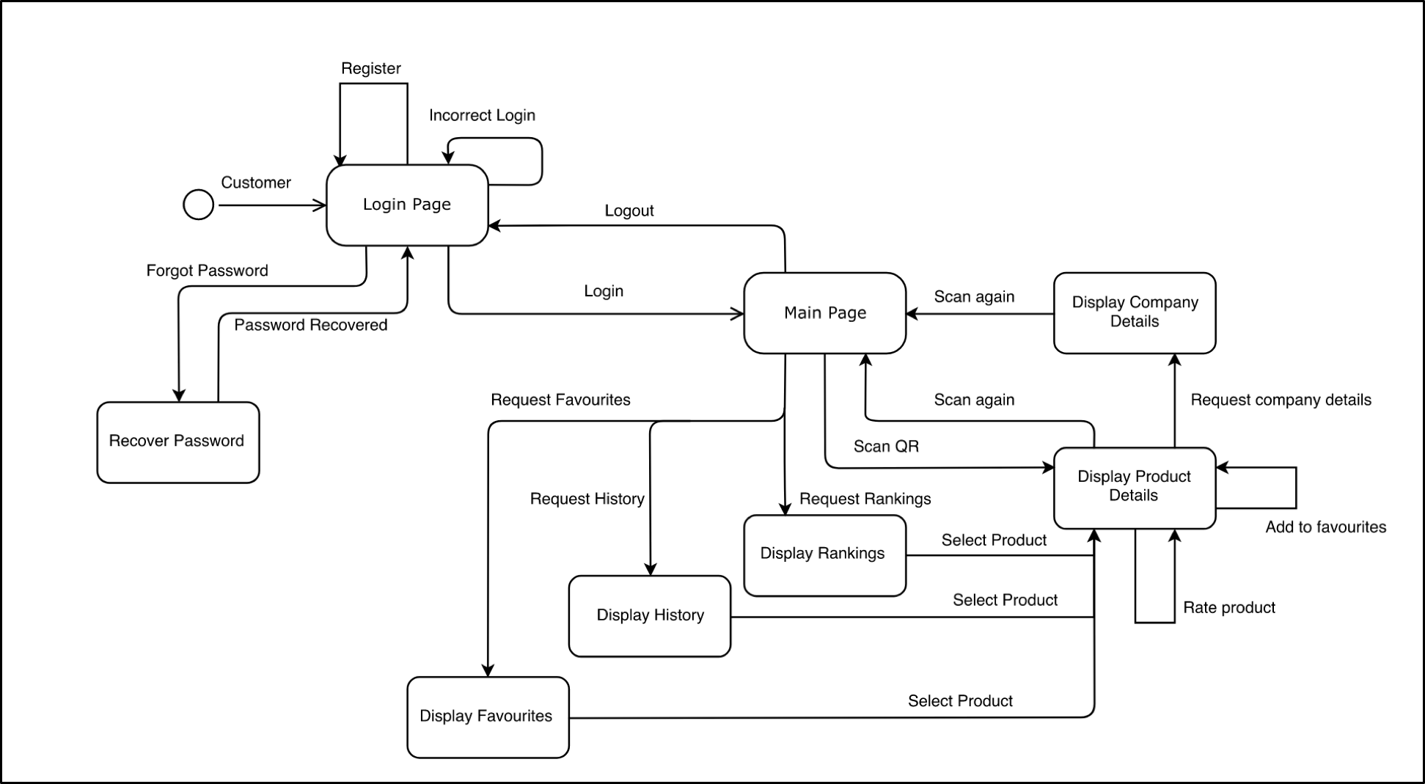

figure 8: state diagram for company owners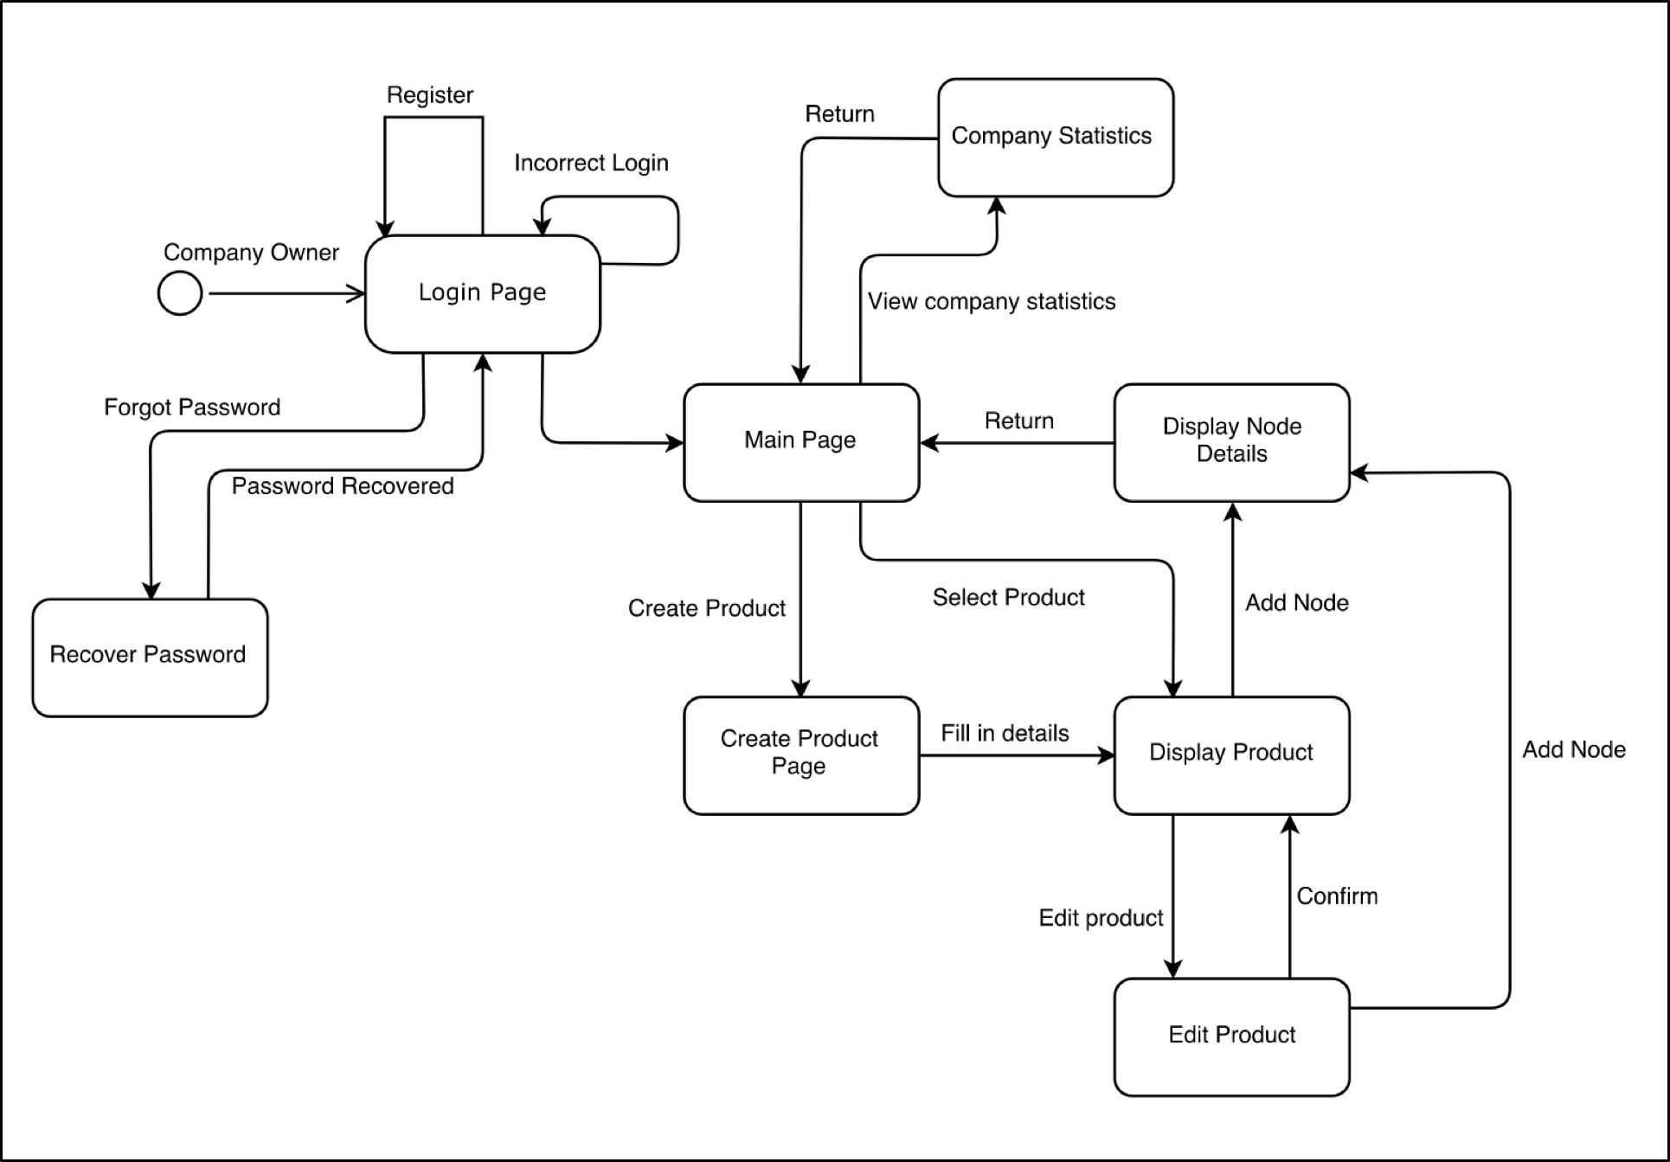

figure 9: collaboration diagram for customers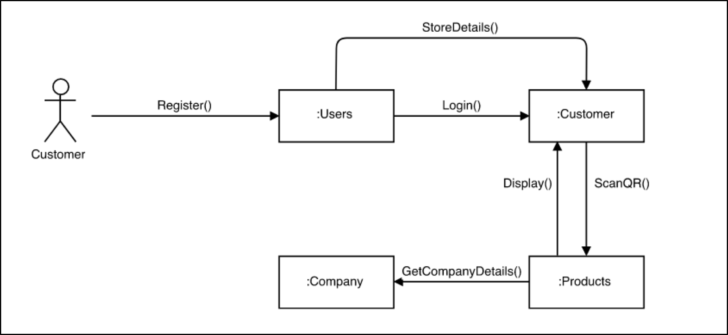

figure 10: collaboration diagram for company owners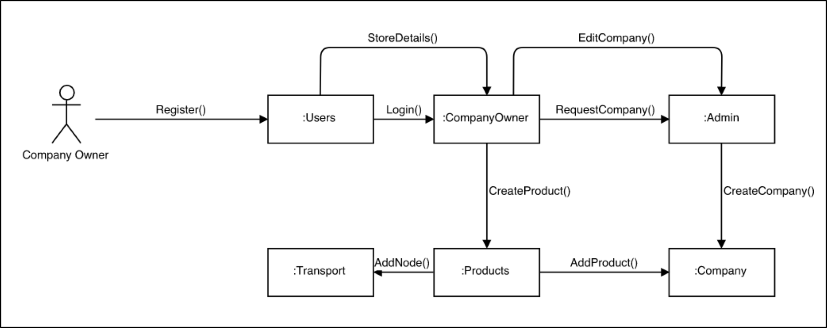

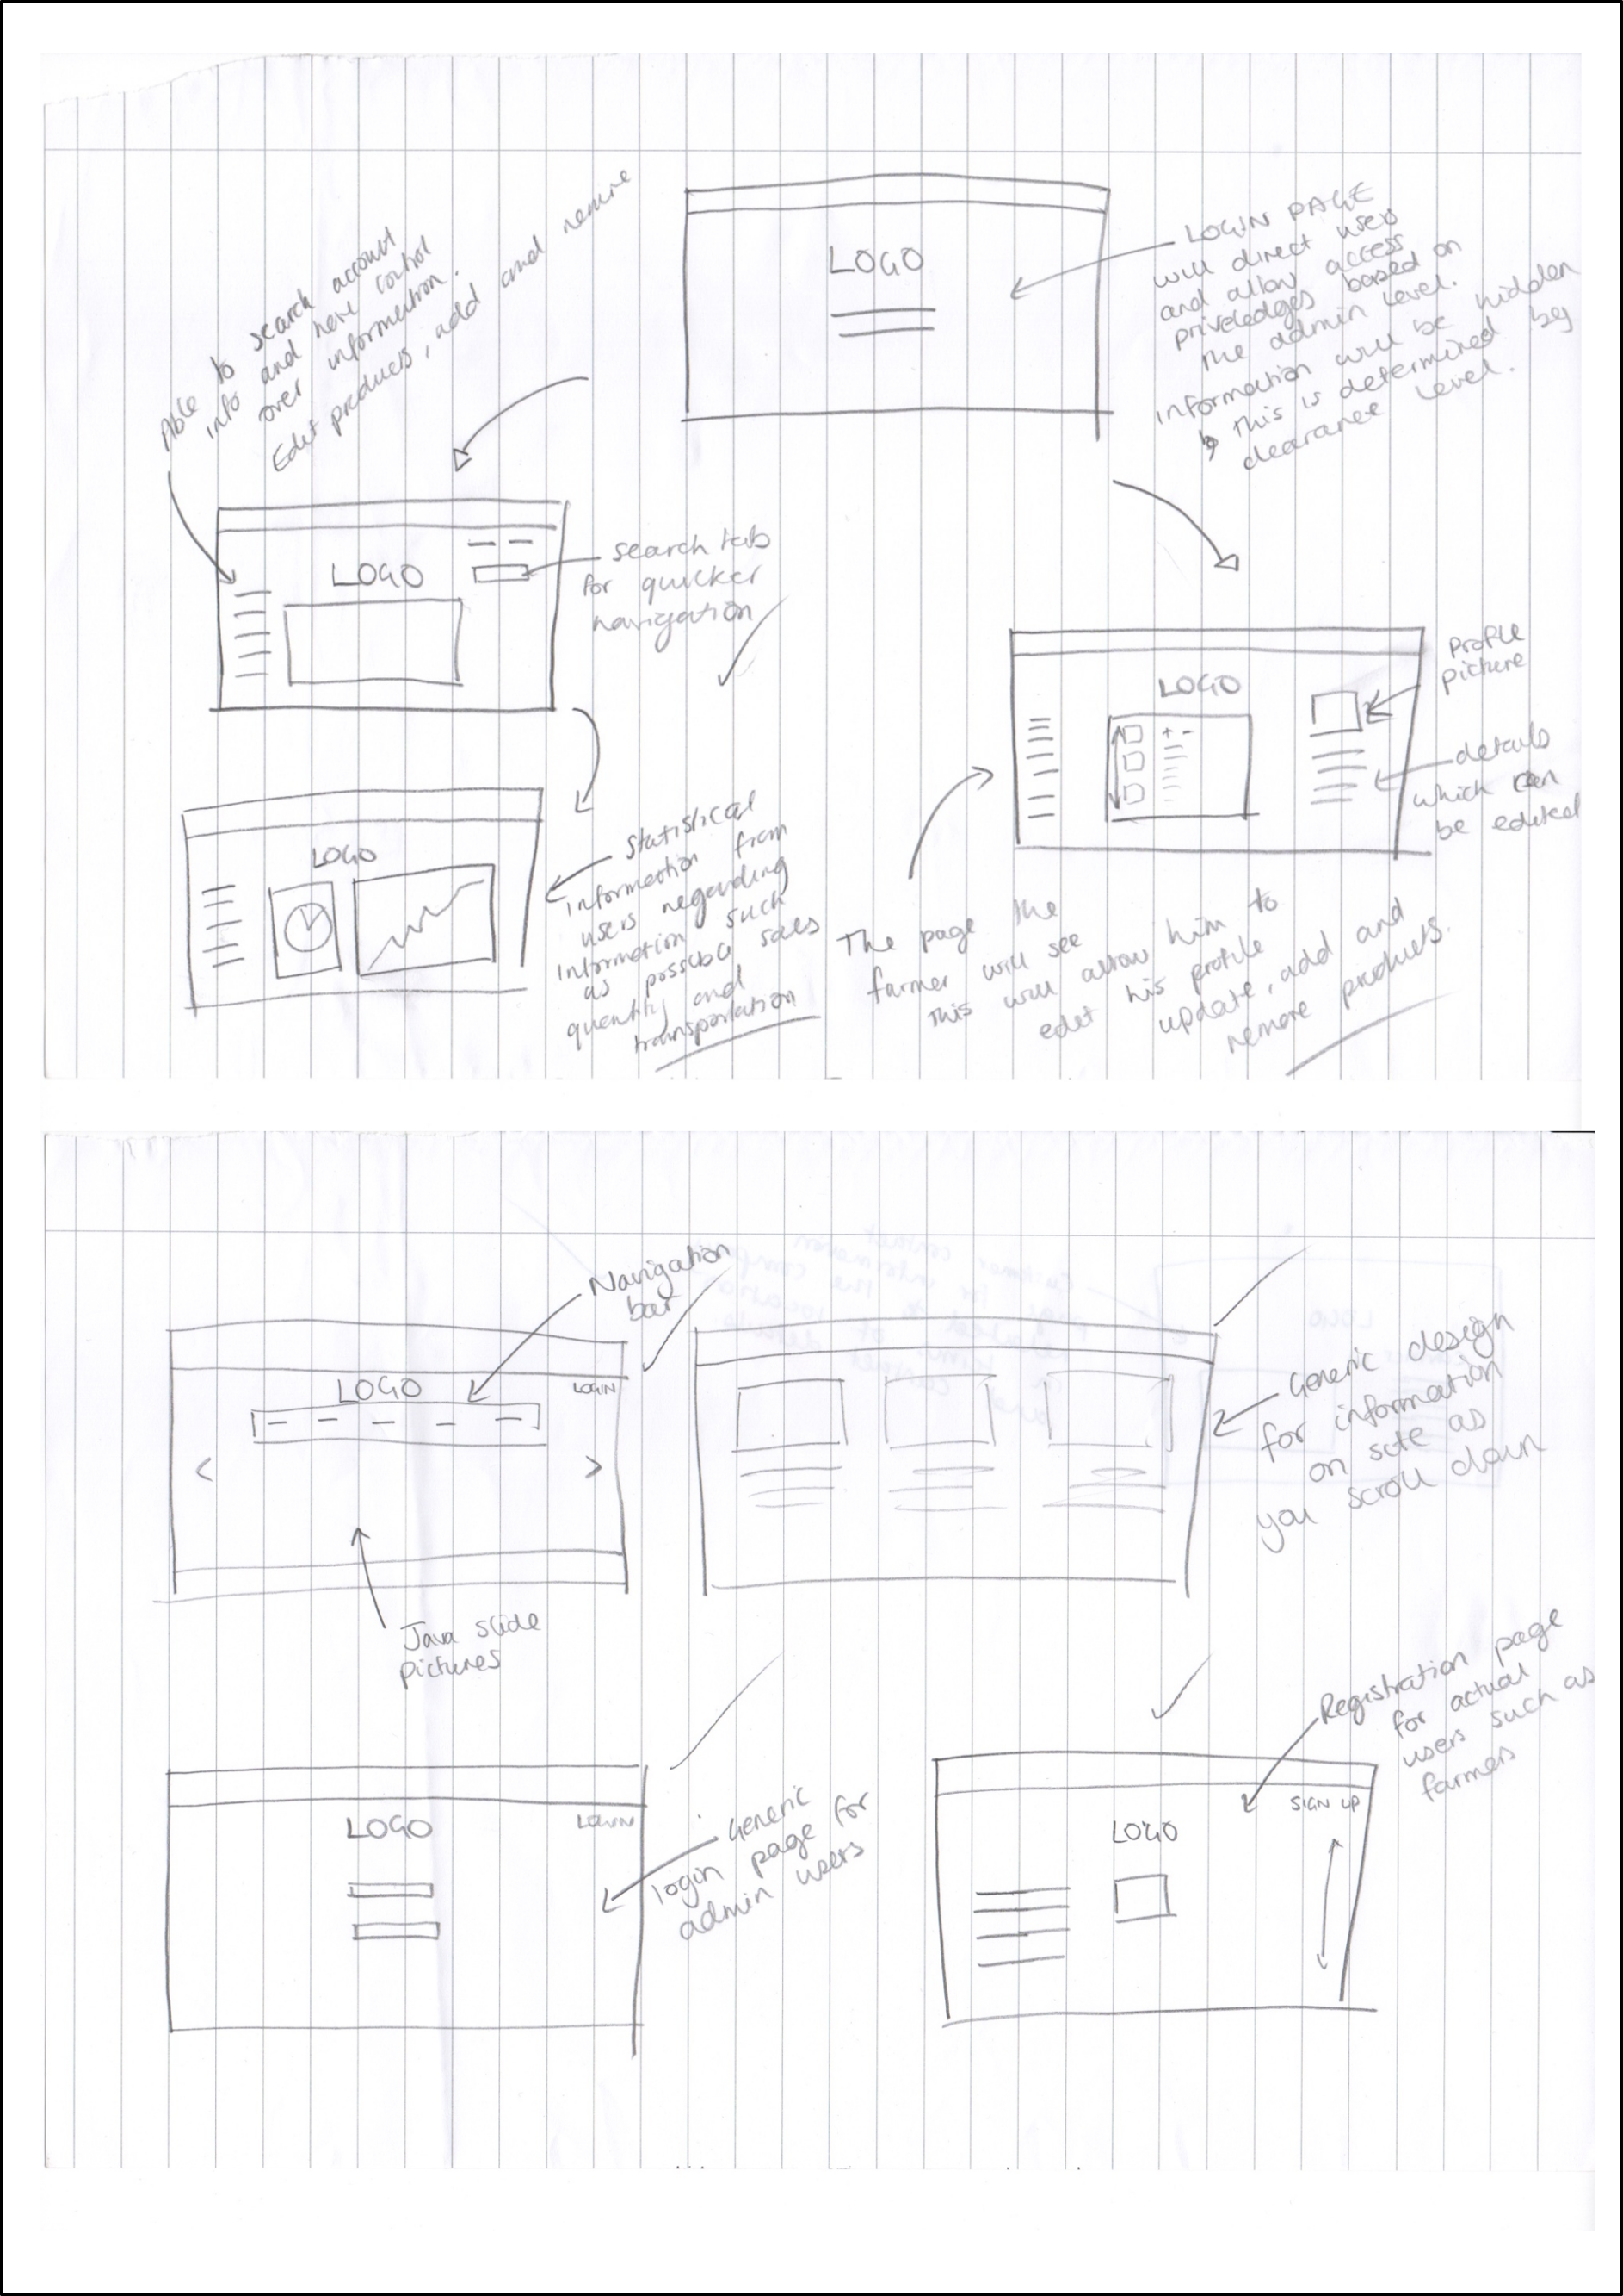

figure 11: paper wireframes / prototypes of website

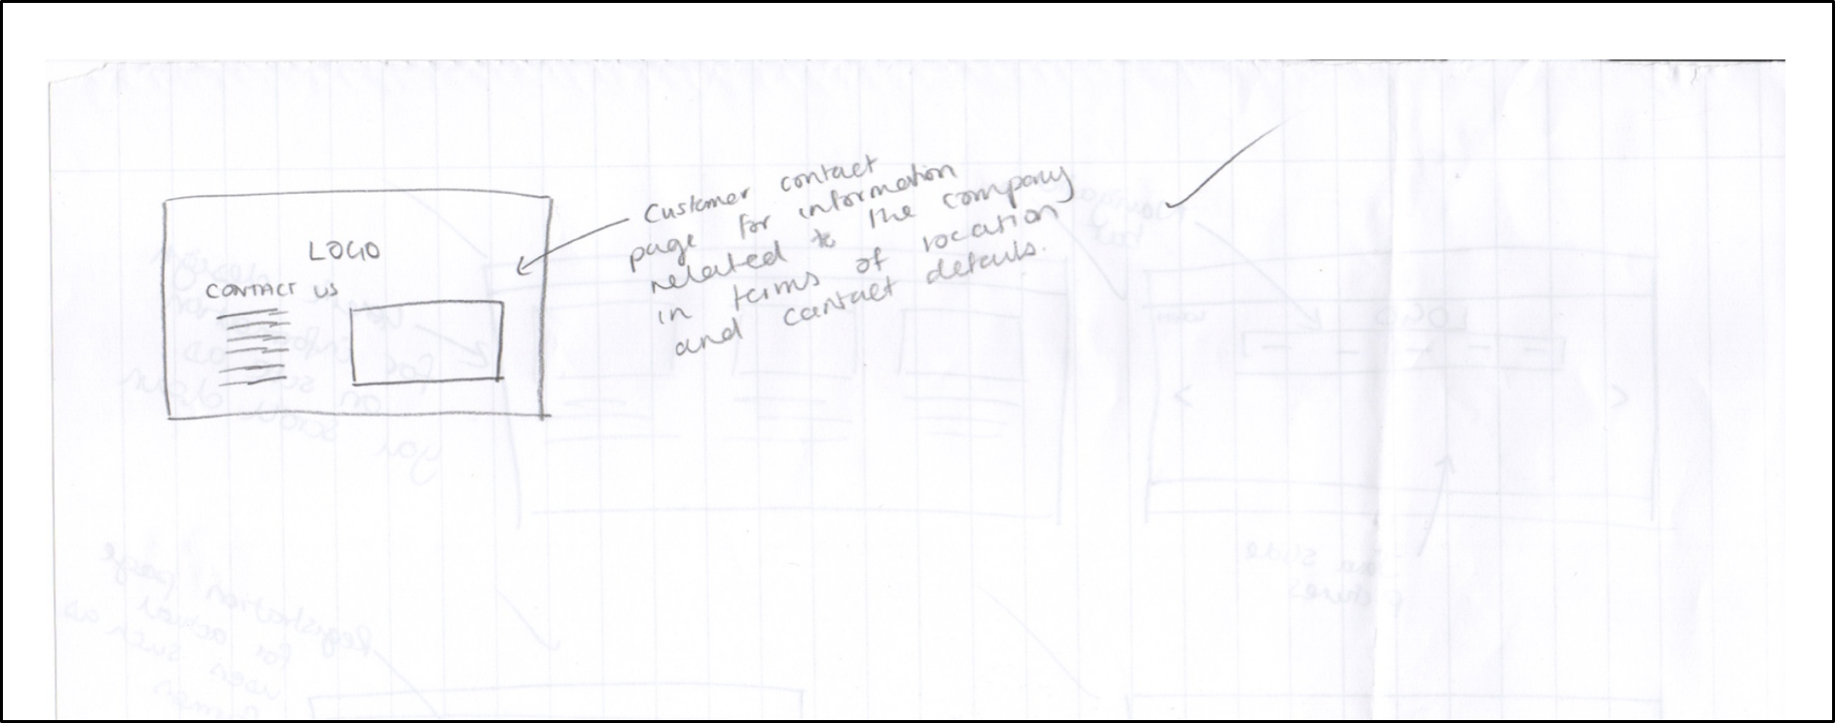

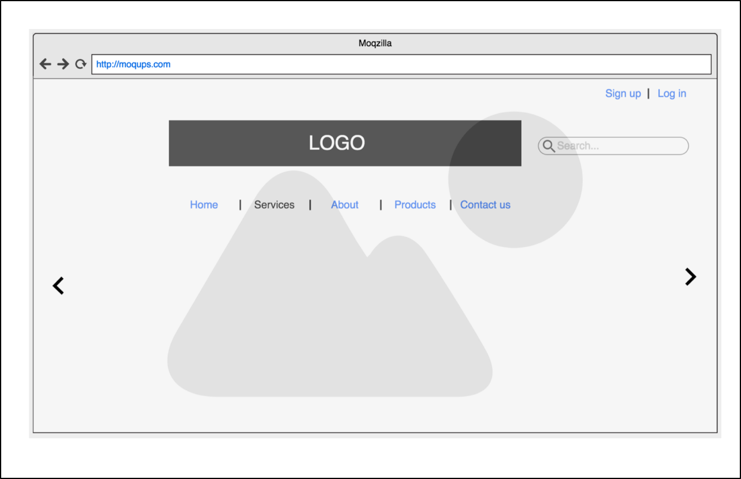

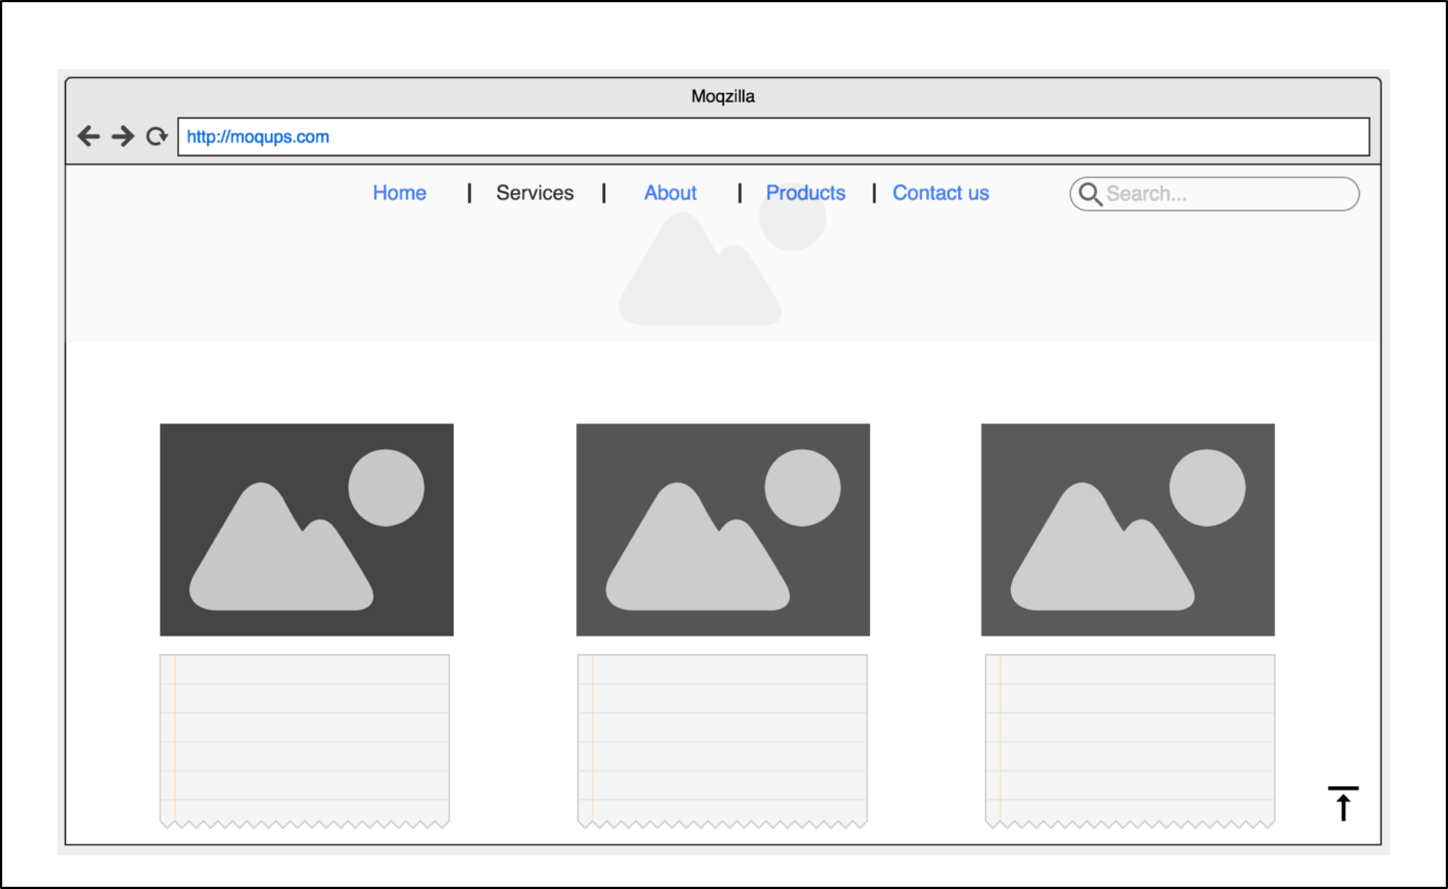

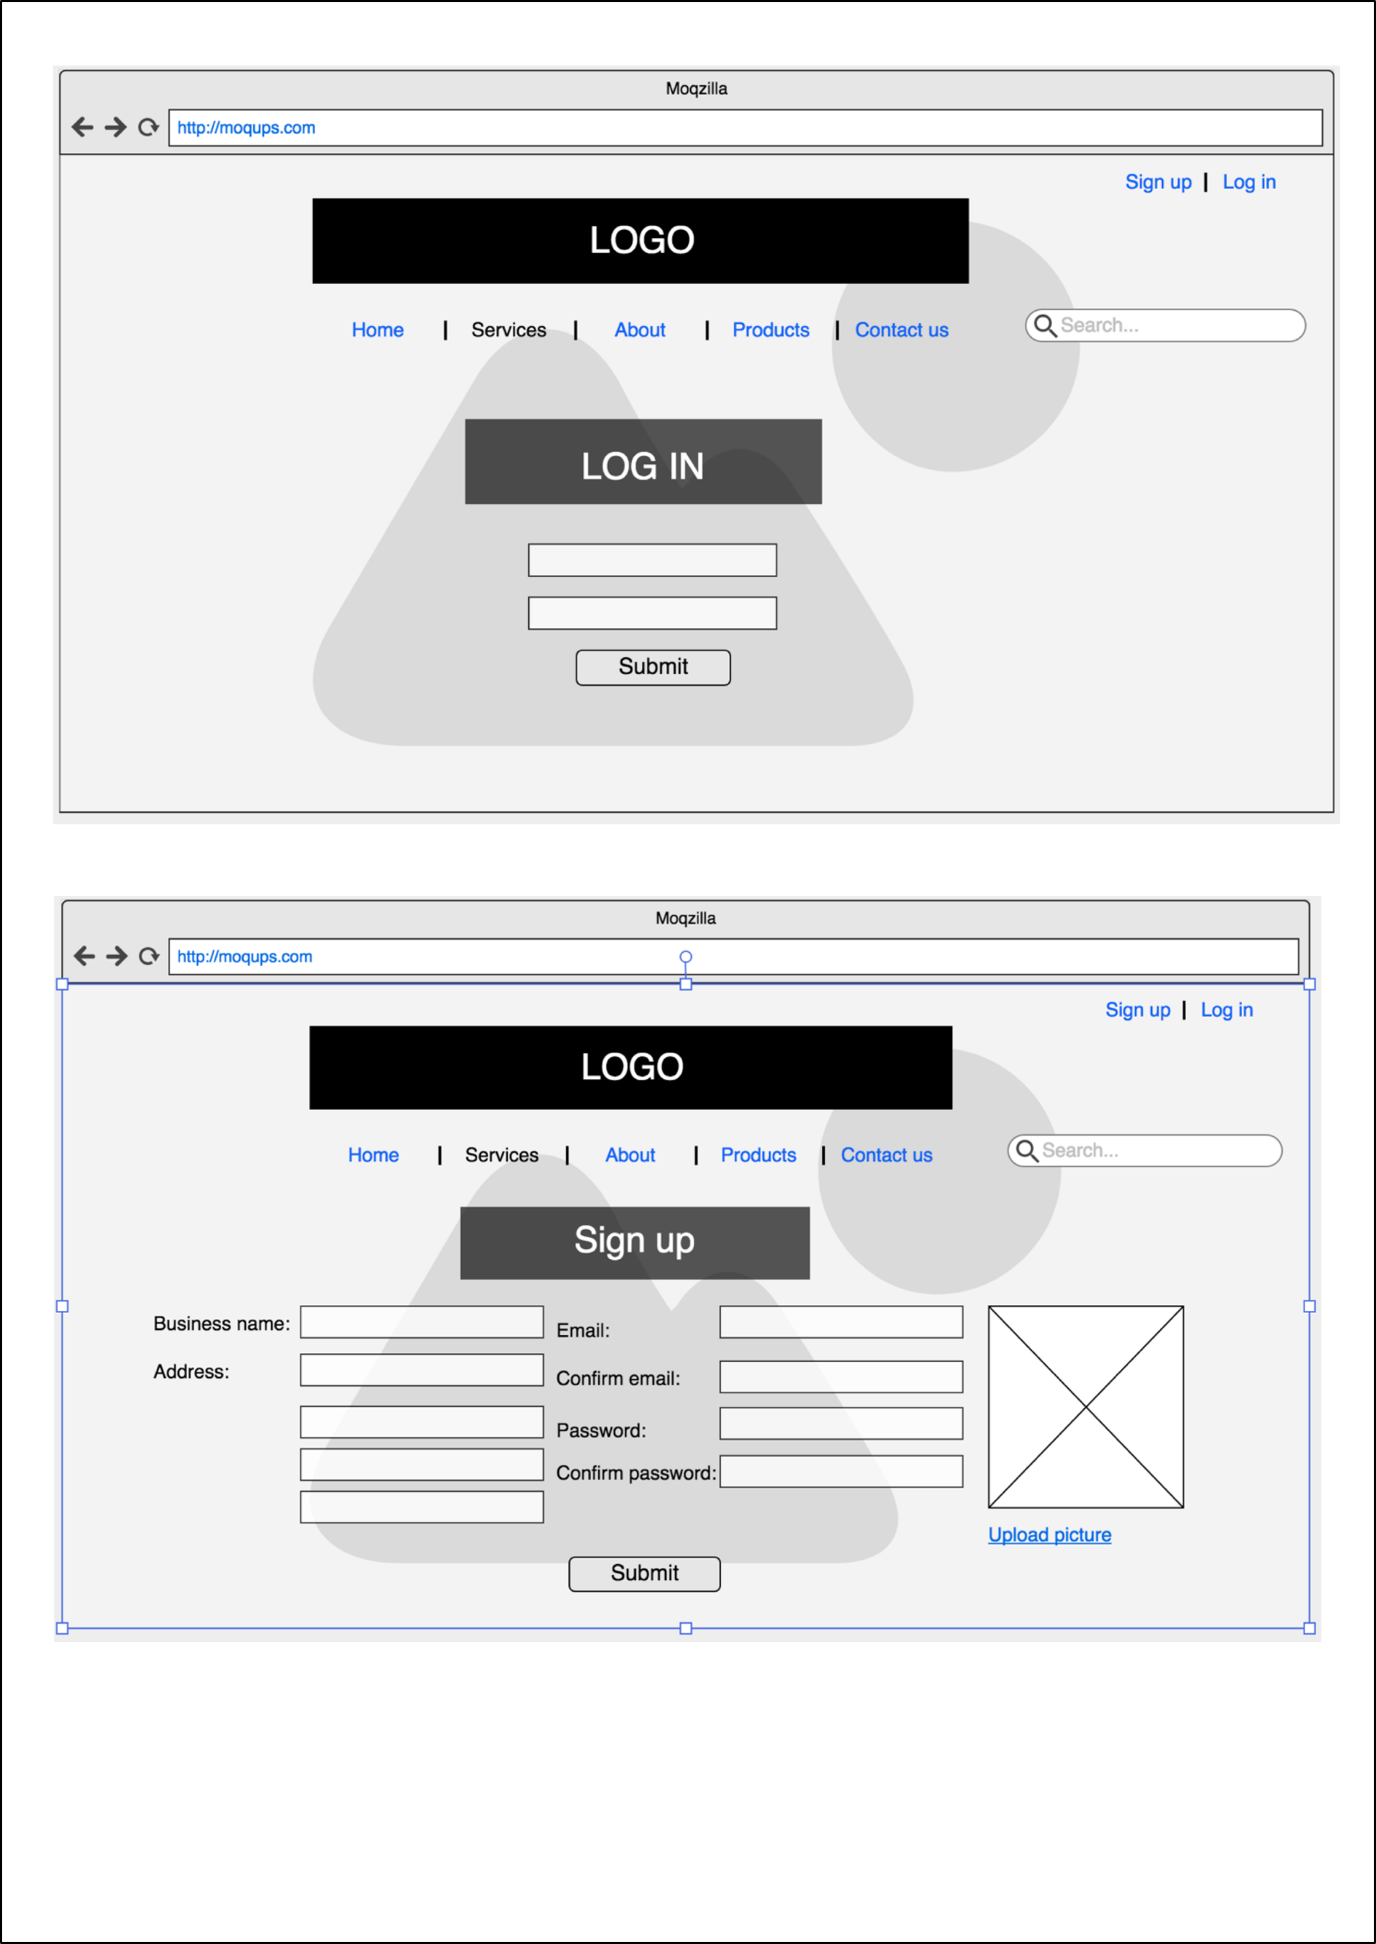

figure 12: digital wireframes / prototypes

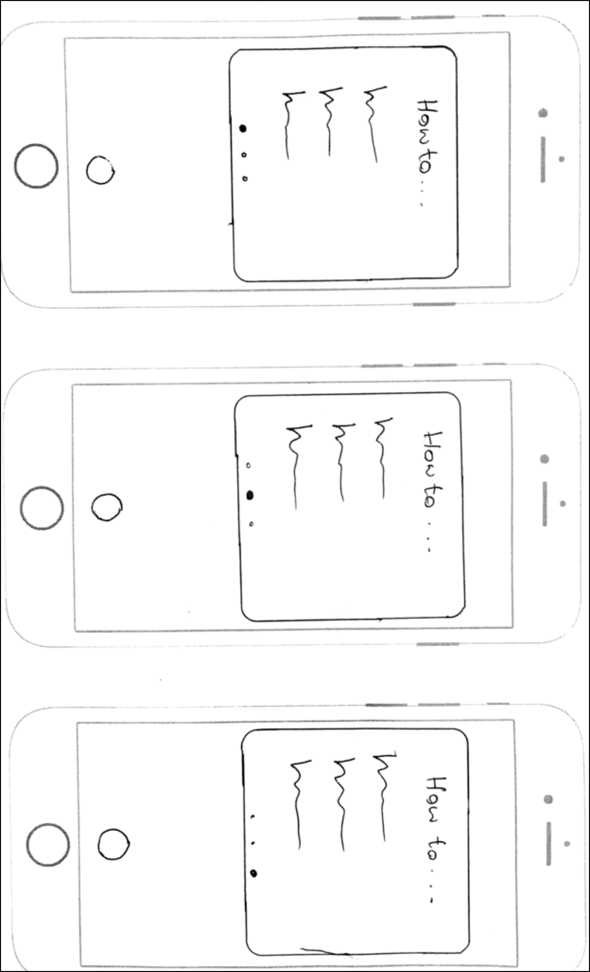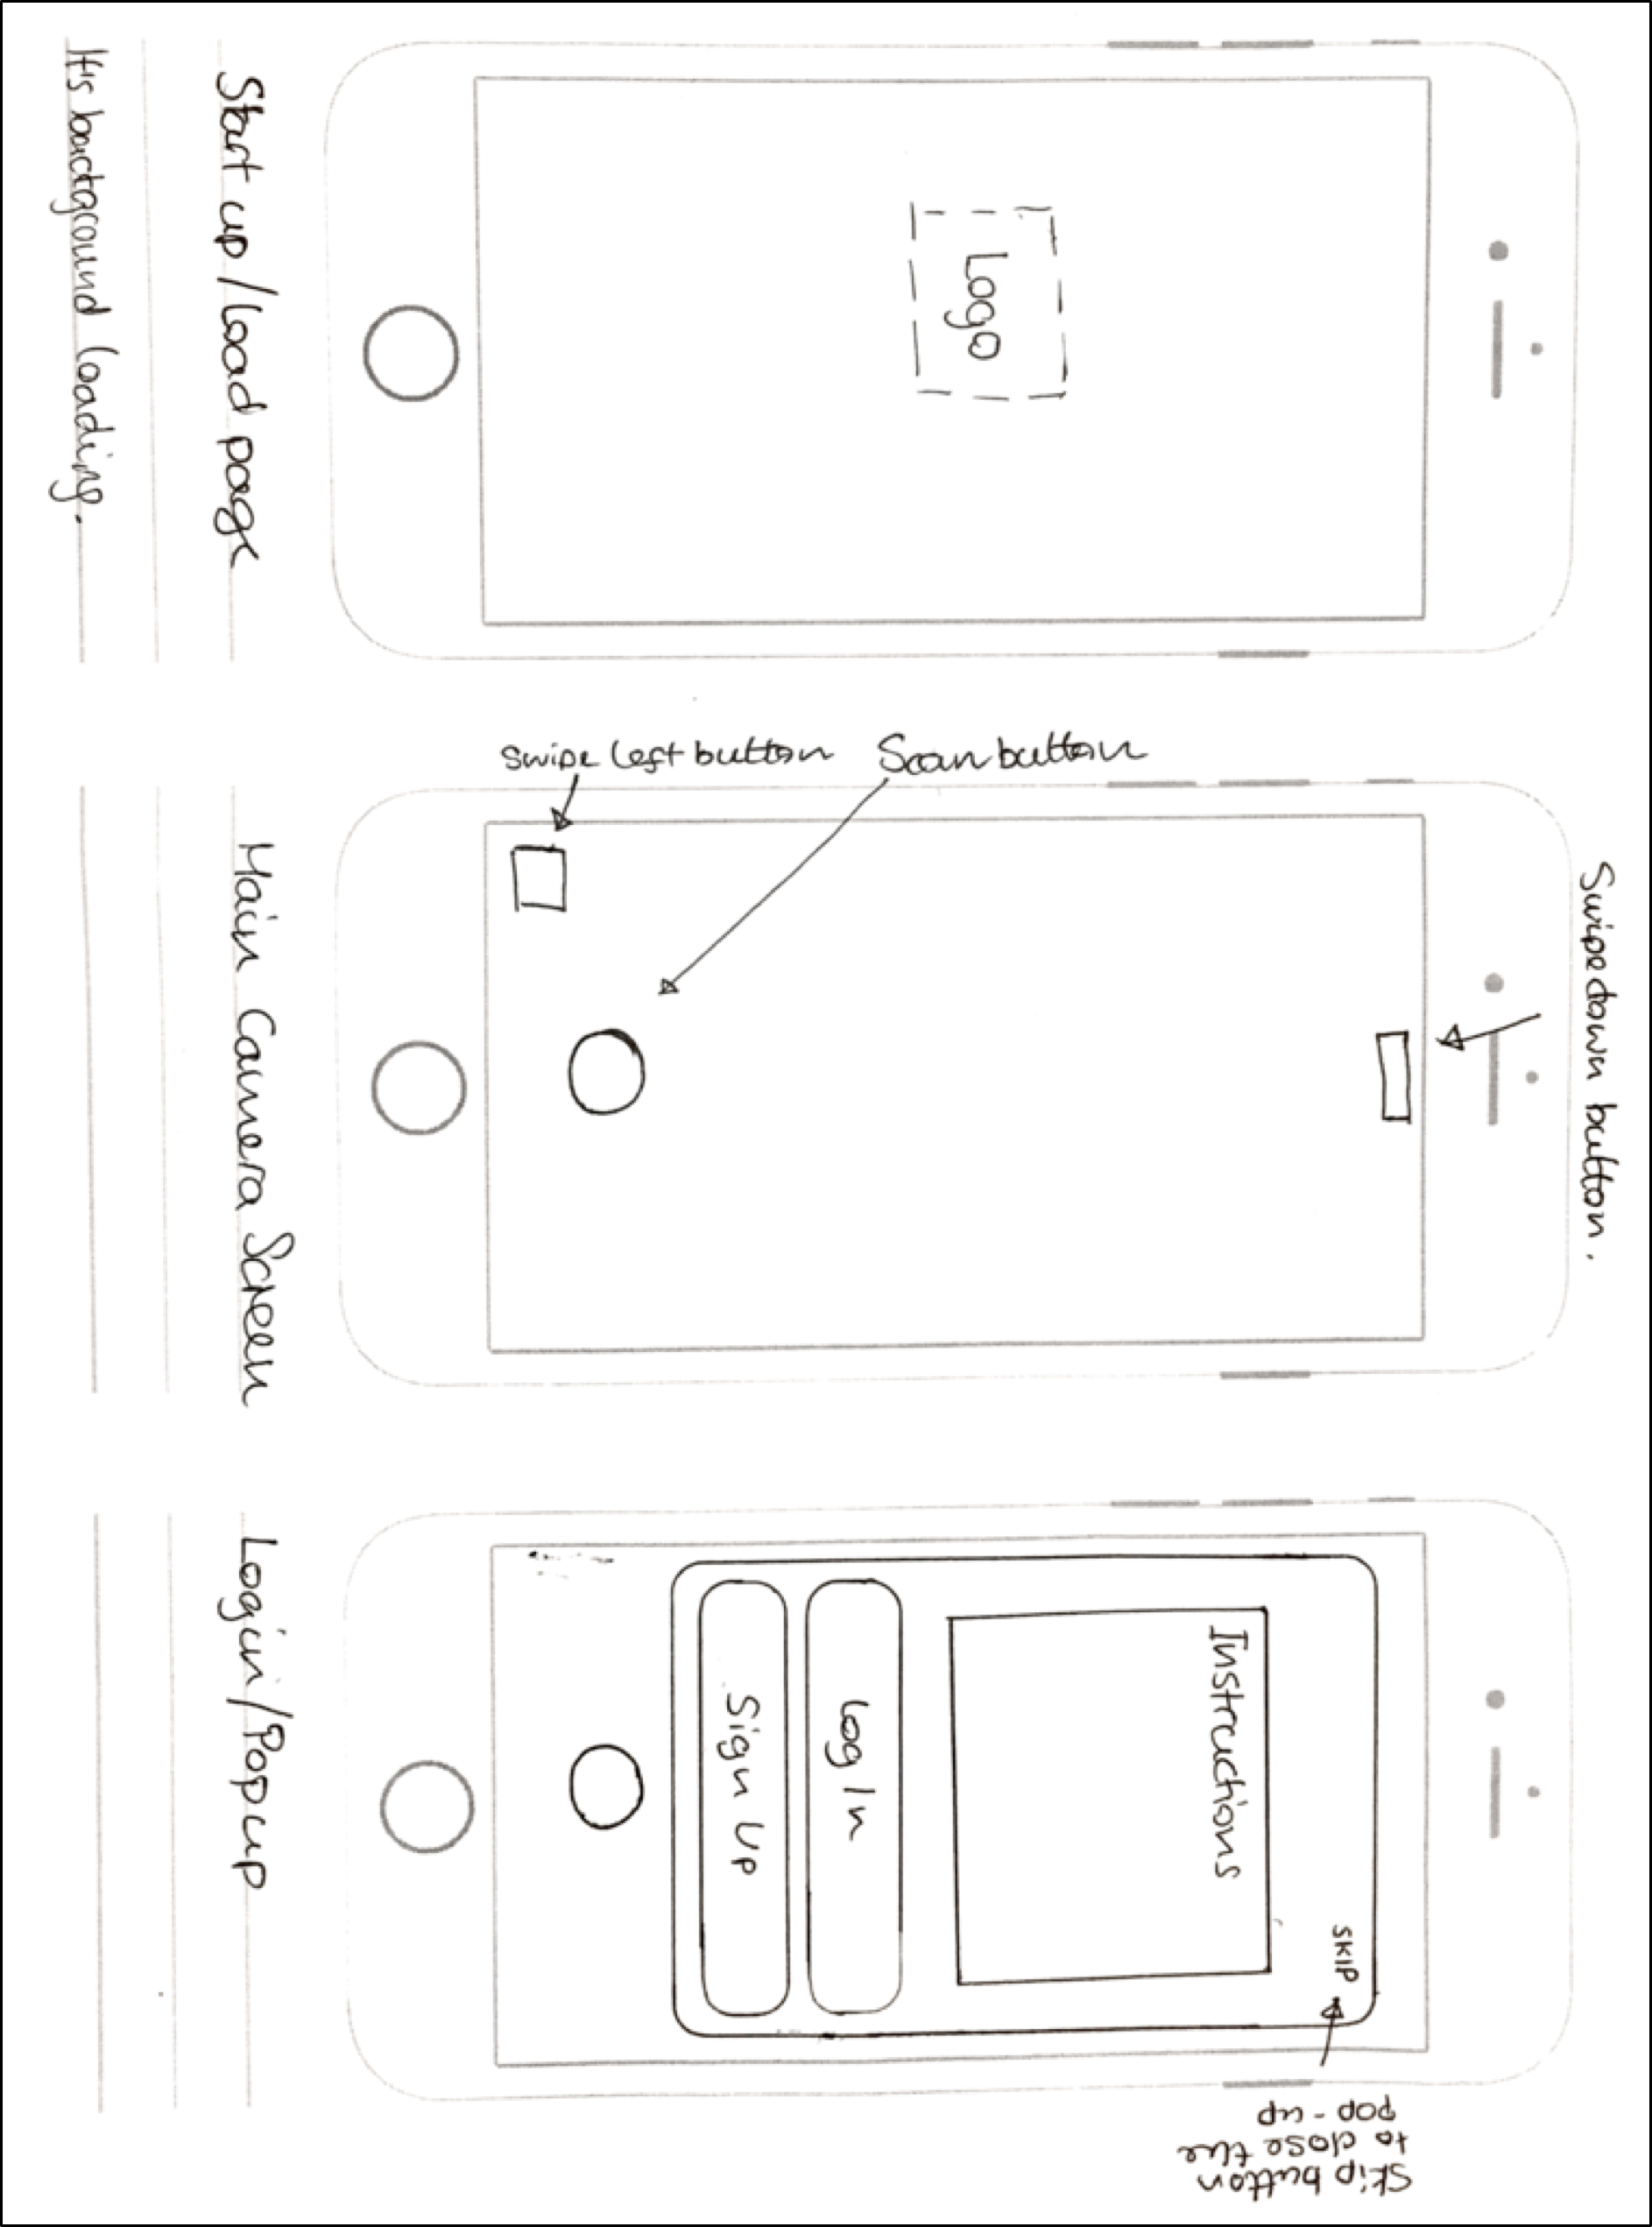

FIGURE 13: PAPER WIREFRAMES 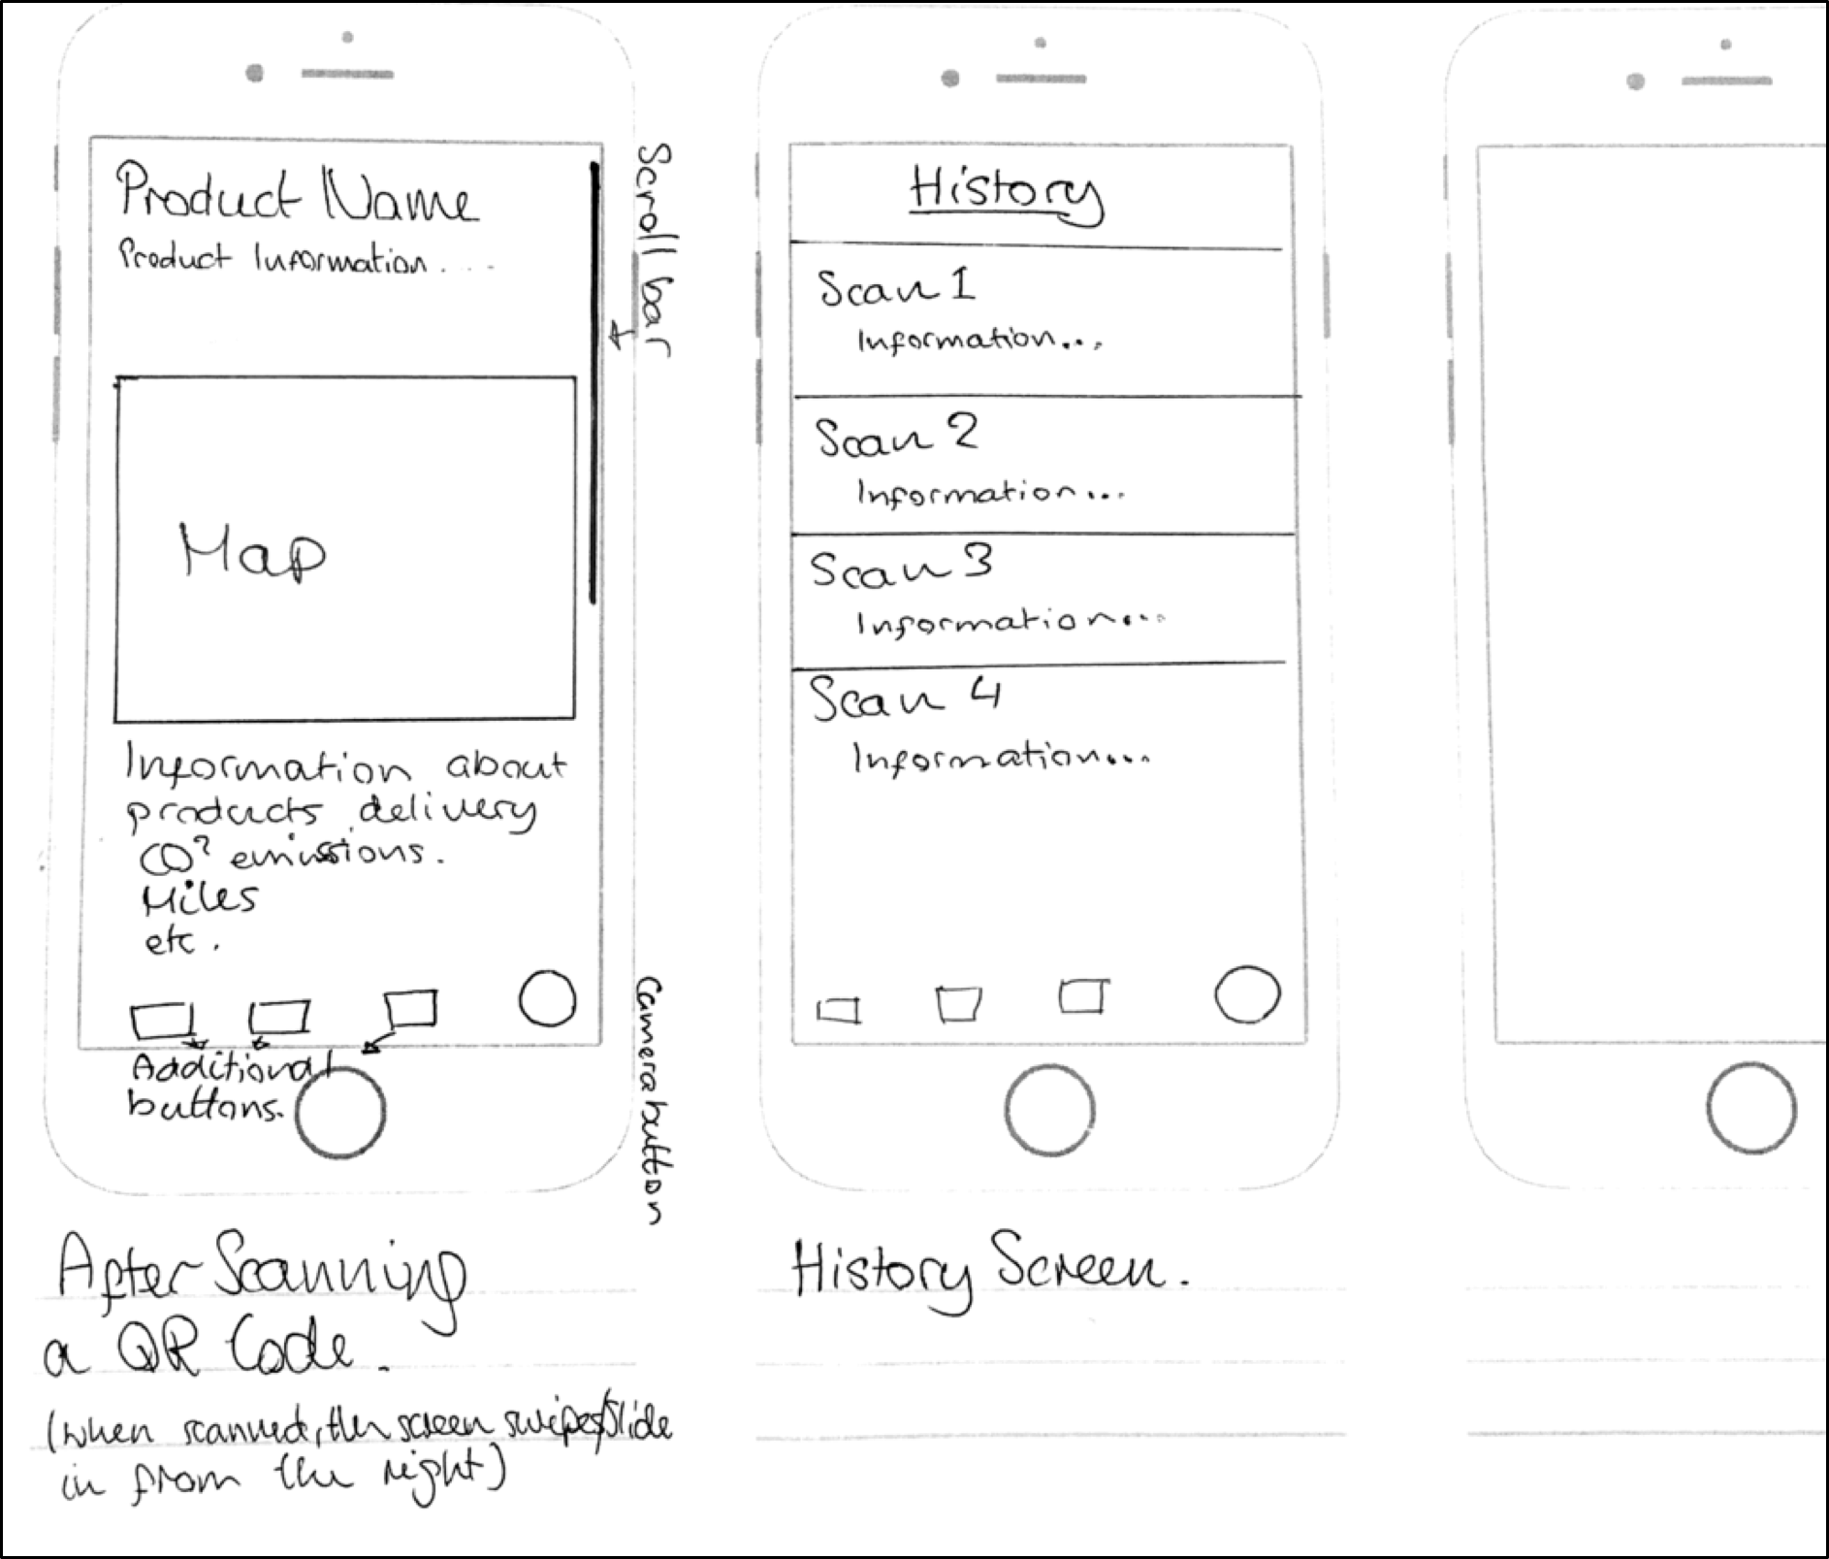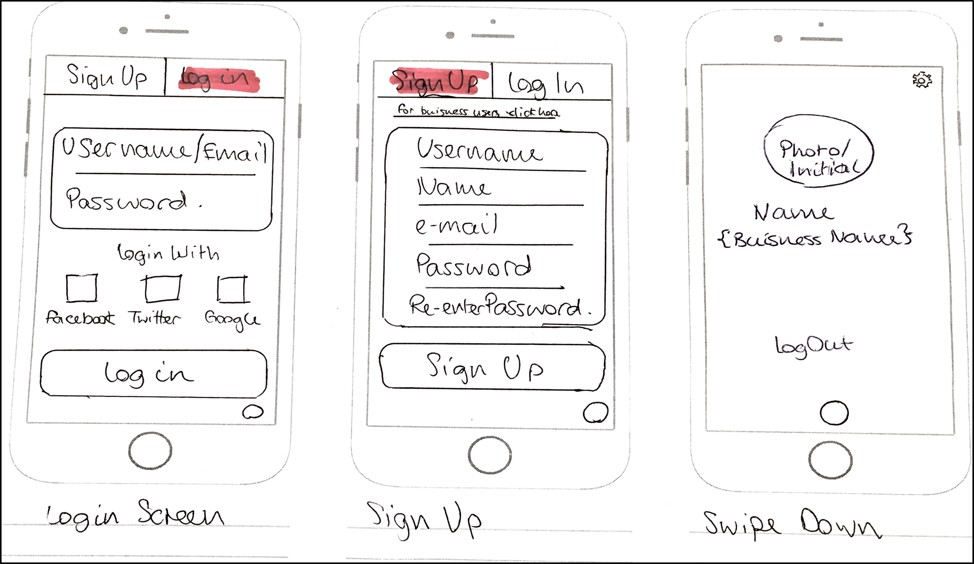/ PROTOTYPES FOR MOBILE APP

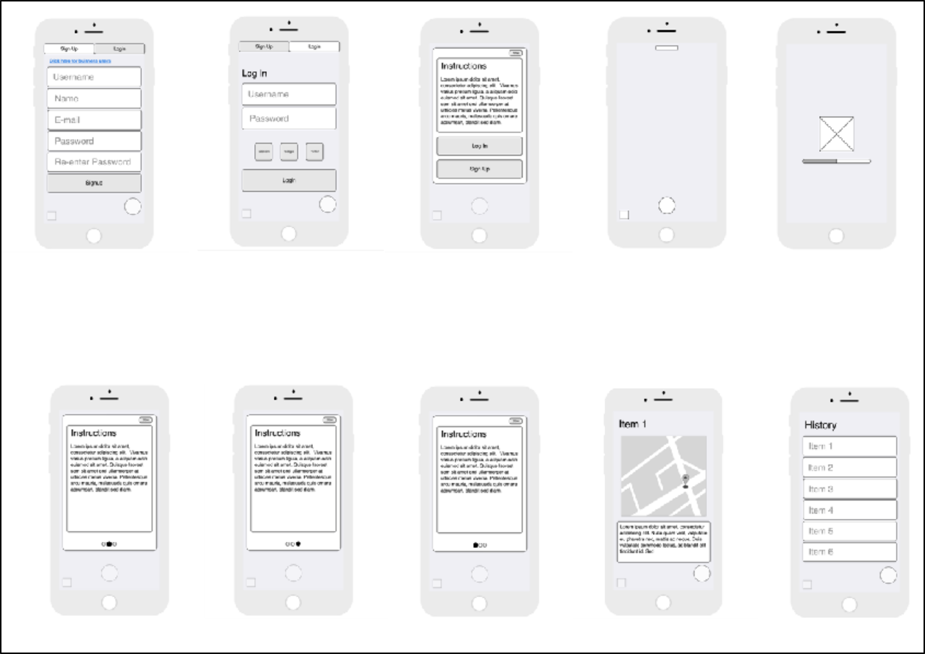FIGURE 14: DIGITAL WIREFRAMES / PROTOTYPES FOR MOBILE APP

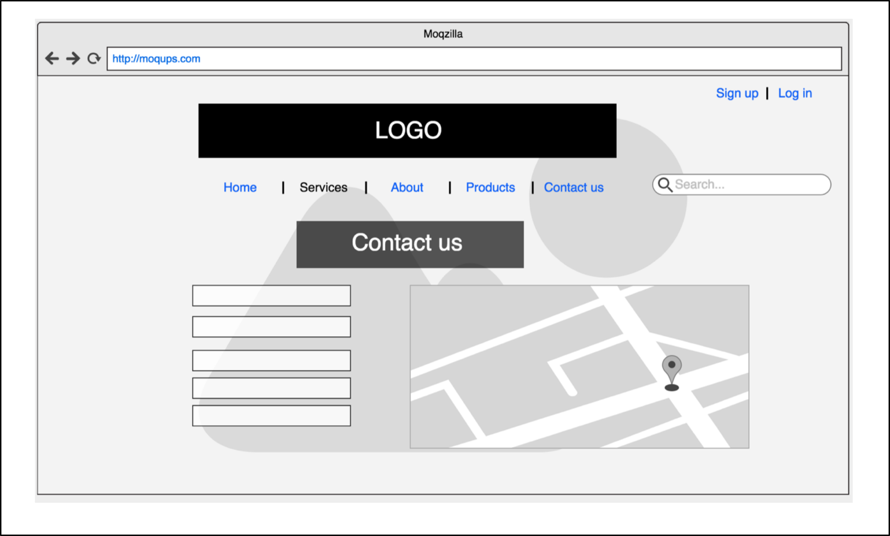

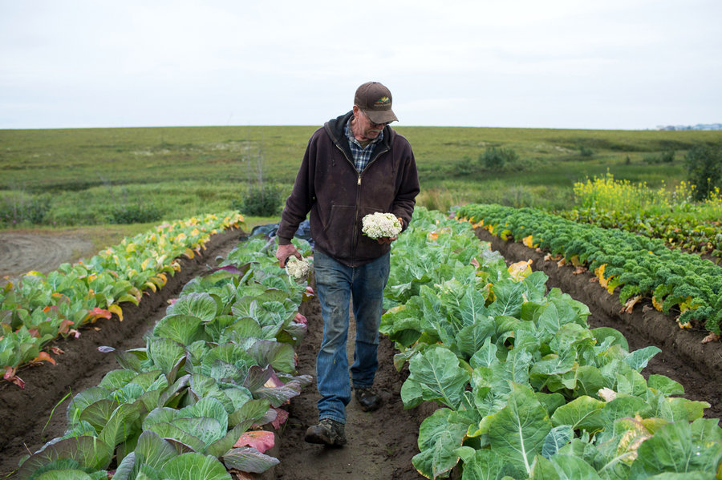

**Name:** Albert Jones

**Occupation:** Farmer

**Age:** 56

**Location:** Yorkshire

**Tier:** Master Farmer

*Introduction:*

Albert is a farmer that has been farming for his whole life and specialises in farming high quality grass fed cows. He is very dedicated to his farm where he also grows root vegetables and sells his products to the local grocery and butchers.

*Goals:*

Albert has a been breeding grass fed cows for a very long time and is trying to expand his business and customer base. He believes his cows are high in value due to the way he farms them. He has advertised his farm online but wants people to be more aware of what he does in his farm and the quality of his products.

*Targets and motivation:*

* Constantly increasing the quality of his products
* Make people aware of the quality of his products
* Be more technologically active
* To get payed the proper value for his products and possibly expand his business to have more customers

*Dislikes:*

* Albert dislikes the direction farming is going such as mass farming and believe its damaging the essence of farming and quality of food being sold to the public.
* He also dislikes companies trying to rip farmers off.

[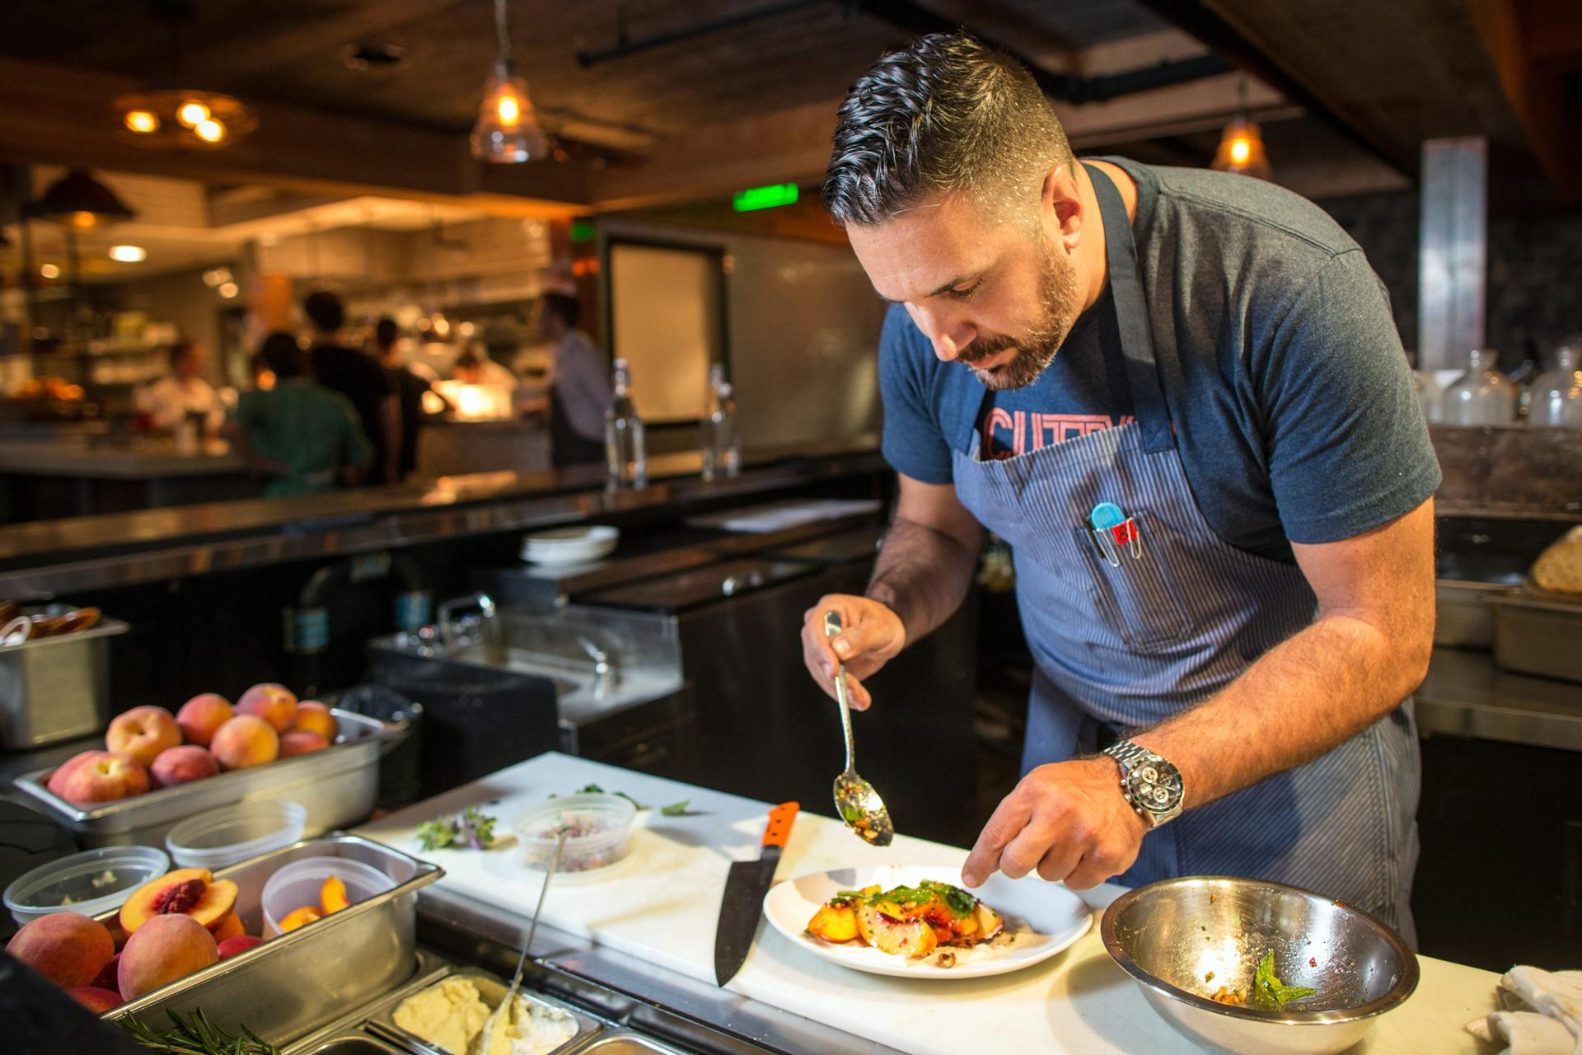](https://camo.githubusercontent.com/e7b809fc210edfdc4847ce6a9f19cf16ed17a9dc/68747470733a2f2f692e70696e696d672e636f6d2f6f726967696e616c732f38392f35642f61302f38393564613037633632323463643461646433383865636131386234326237362e6a7067)

**Name:** Wilson McKenzie

**Occupation:** Store/Café/Restaurant Owner

**Age:** 29

**Location:** London

**Tier**: Owner/Manager

*Introduction:*

Wilson is a young entrepreneur whose opened his own grocery store where he sells high quality organic grocery products sourced from local area and believes that local small businesses should help each other and offer better and healthier products to local communities.

*Goals:*

Wilsons goal is to make people more aware of the products that they buy as he states all possible information available about products he sells. He’s trying to implement a better technological interaction with his customers. *Targets and motivation:*

* Promote local businesses and organic products
* Make people aware of items that they buy
* Customers that support his vision of quality and community

*Dislikes:*

* Wilson is against selling products that are not of decent quality.
* He also dislikes businesses who do not care for their customers and use mass production.
* He also doesn’t like “fake” foods which are full of chemicals and bad for your health



**Name:** Elvis Green

**Occupation:** Liberal arts student

**Age:** 22

**Location:** London

**Tier:** Hipster

*Introduction:*

Elvis considers himself a hipster. He is an independent-thinker that values counter-culture, progressive politics and has an appreciation of art, creativity, intelligence and witty banter. He rejects the culturally-ignorant attitudes of mainstream consumers He follows the latest trends and fashion especially those regarded as being outside the cultural mainstream.

*Goals:*

Eat healthy. He would rather go to a small independent shop rather than a big supermarket to buy his groceries even though he knows it’s more expensive, so he can help the small businesses. Also, he promotes healthy eating in his friend circle and always suggests what to eat and where.

*Targets and motivation:*

* Healthy eating
* He likes the warmness and friendliness of a small shop rather than a big chain where he feels more valued
* Helps local businesses and promote organic food in his community

*Dislikes:*

* Big chains and superstores
* Pollution
* Food full of artificial ingredients
* Mainstream stuff
* Trump

[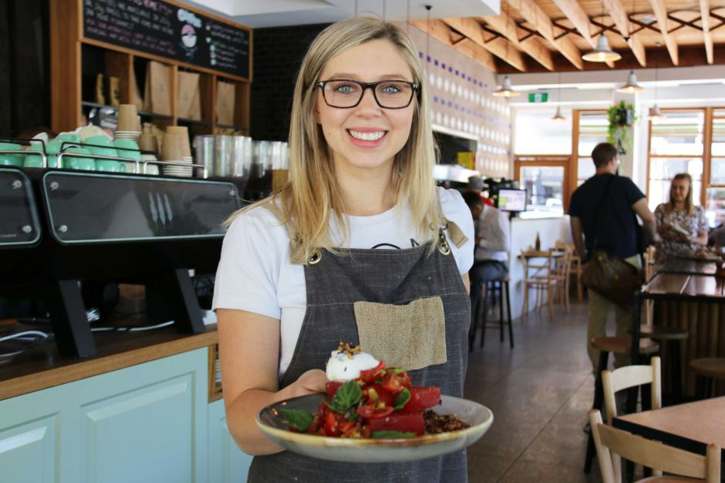](https://camo.githubusercontent.com/c9c08c1d599c78bccc355a46d670e37961cad82a/687474703a2f2f7777772e6162632e6e65742e61752f6e6577732f696d6167652f373032383034302d3378322d393430783632372e6a7067)

**Name:** Ellie Marsh

**Occupation:** Supervisor

**Age**: 27

**Location**: London

**Tier:** Hospitality worker

*Introduction:*

Ellie works in hospitality and her schedule can be busy or quiet depending on the hours she is doing every week. When she is busy she does not have time to cook so she would rather eat out or buy ready-made food. On her quiet days she’d rather go to the local grocery store and buy organic food, cook and eat at home.

*Goals:*

She would love to eat healthy but due to her schedule she does not have the time to do so. She is not really fussed about where the products are from and how are they made but whenever is in the situation to pick from 2 of the same products she always picks the organic one and the one that is fair trade. By doing this she does not feel as guilty.

*Targets and motivation:*

* Healthy eating
* She likes the friendliness of the local shops and cafes as she can chat with the owner about the products

*Dislikes:*

* “fake food”
* pork because she thinks pigs are cute
* complicated tasks, she would like to have everything at a click of a button
* lack of information

**Figure 15: Example of personas (mentioned in data gathering).**

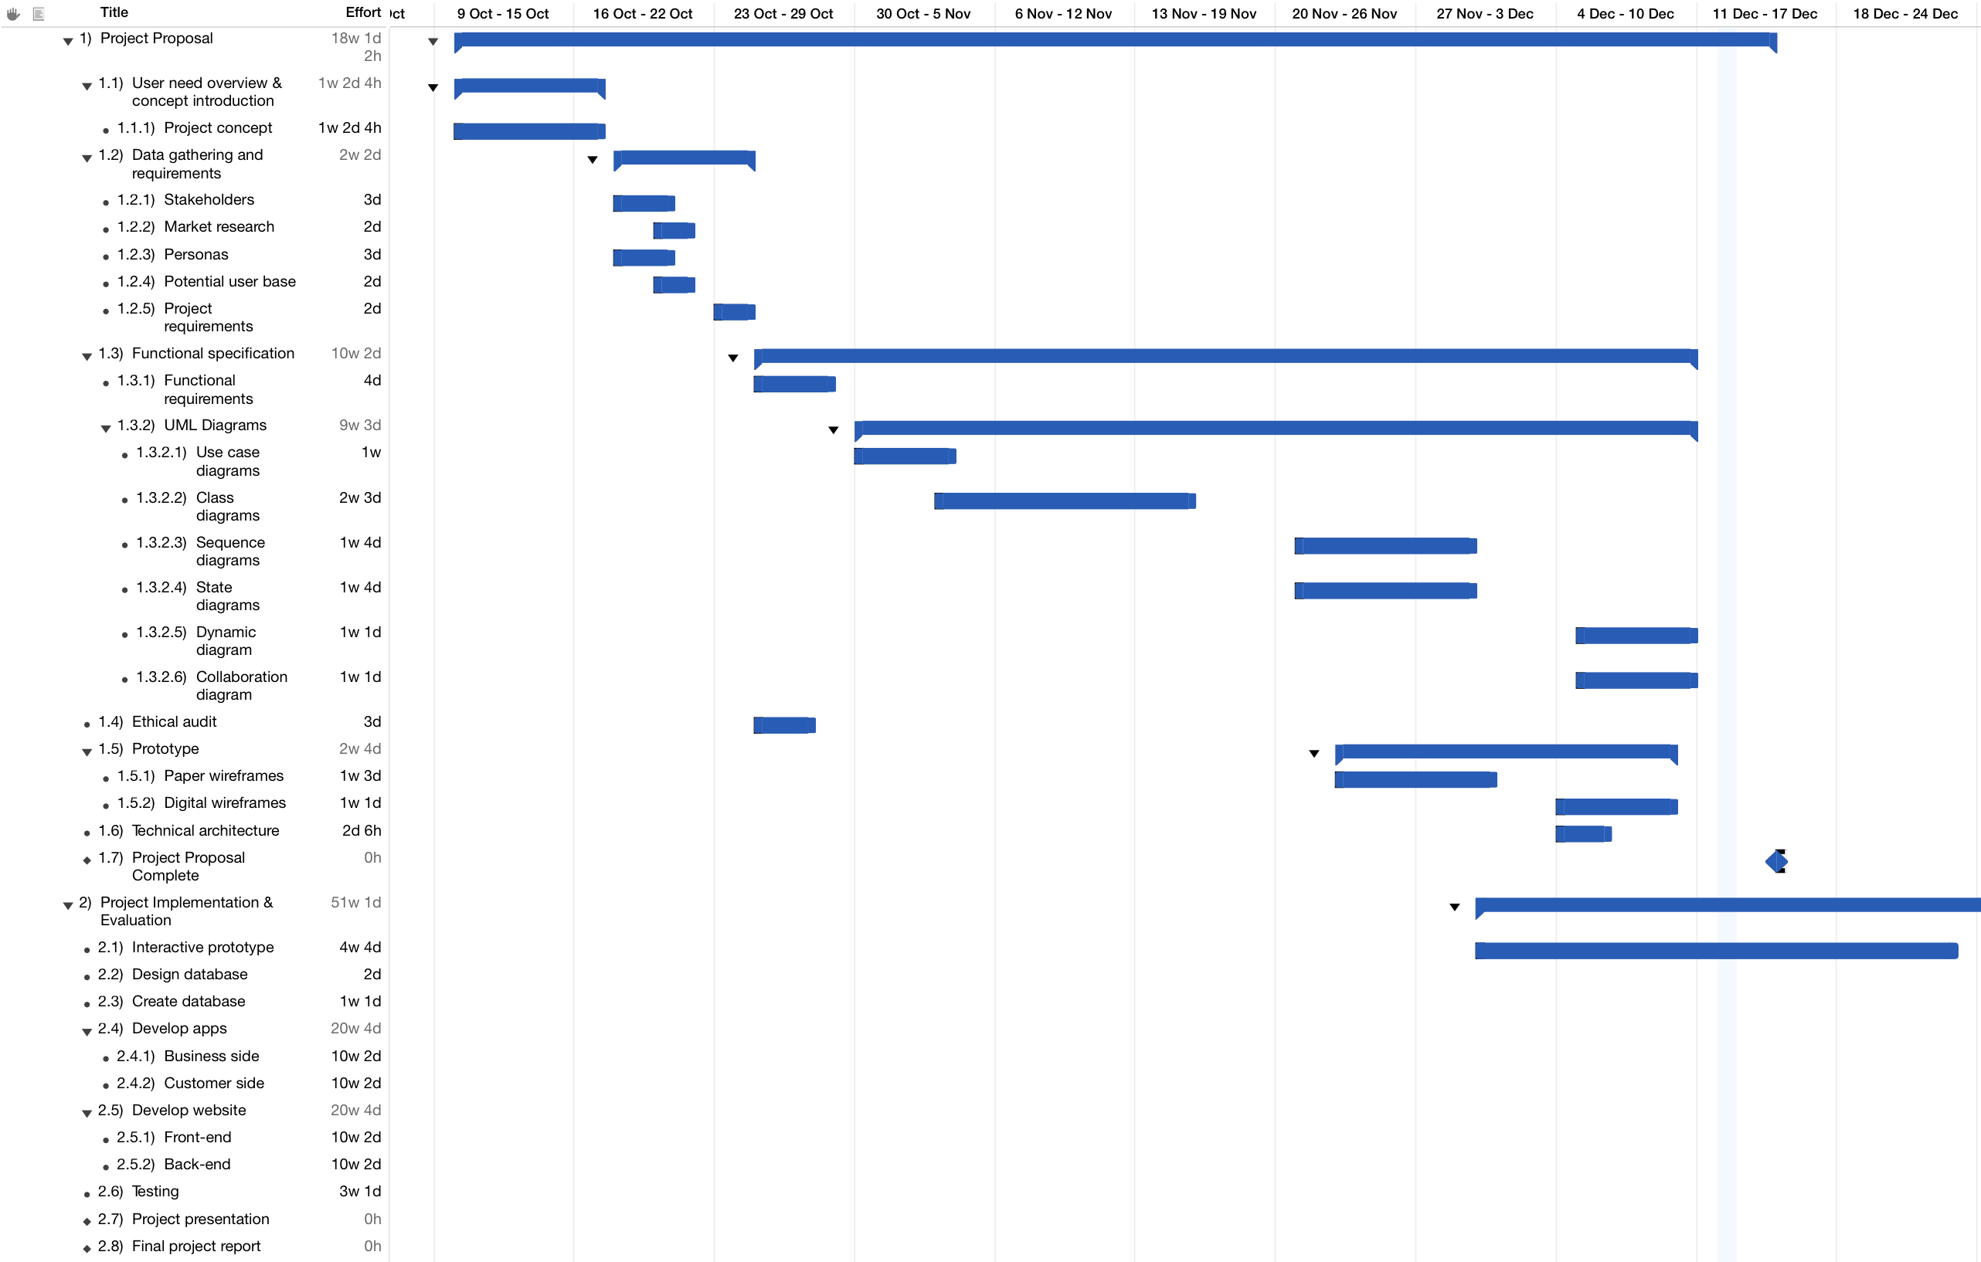

**Figure 16: First half of gantt chart up until the project proposal.**

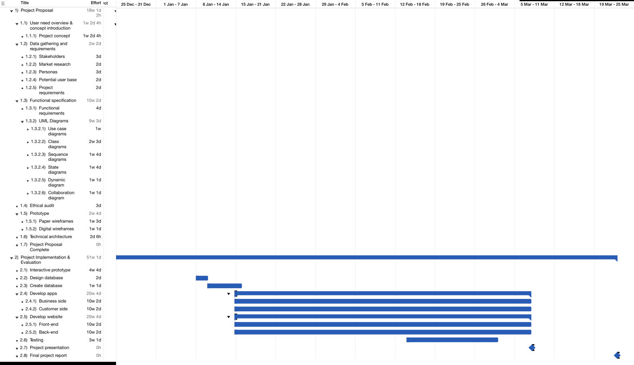

**Figure 17: Second half of gantt chart up until the the end of the project.**



**Figure 18: Image of the titles of the sections in gantt chart (refer to figure 16 and figure 17).**